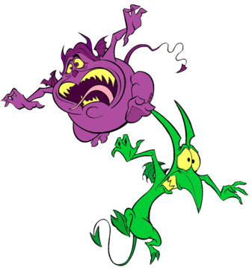
What is going on be on the Honors Physical Science exam on May 30th at 8:30am?!?!?!!?
- Unit 8 – Atomic Theory and Structure
  - Scientists (Democritus, Dalton, Rutherford, Bohr, etc…)
  - Atomic/Isotope structure (subatomic particles and nuclear notation)
  - Calculating Average Atomic mass
  - Electron Configuration (don’t forget exceptions!)
  - Bohr Model calculations
- Unit 9 - Classification of Matter and Periodic Trends
  - Chemical/Physical changes and properties
  - Mixtures/pure substances
  - Periodic tables families (metals, nonmetals, etc.)
  - Reactivity, atomic radii, ionization energy, electronegativity, ionic radii
  - Lewis Structures (atoms AND ions)
- Unit 10 - Chemical Bonding
  - Nomenclature rules for ionic and covalent (know prefixes)
  - Writing chemical formulas for ionic and covalent (given polyatomic sheet)
  - Lewis dot structure of compounds
  - Molecular Geometry (shapes!)
  - Polarity (given electronegativity charts)
  - Metallic Bonding
- Unit 11 – Nuclear Chemistry
  - 3 Types of Nuclear decay equations
  - Fission/fusion
  - Graphing and solving half-life
  - Solving for mass defect
- Unit 12 – Chemical reactions
  - Calculating percent composition and empirical & molecular formulas
  - Writing and balancing chemical equations
  - Identifying types of reactions
- Unit 13 – Stoichiometry and Quantitative Analysis of Equations
  - Using solubility chart and activity series to predict products/write equations with state symbols
  - Stoichiometry
  - Calculating Limiting Reactants
- Unit 14 – Stars and Solutions
  - Life cycle of a Star and HR diagrams
  - Calculating molarity and dilutions
  - Reading solubility graph
  - Saturated, unsaturated, and supersaturated solutions
  - Factors affecting solubility
  - Distinguishing between acids and bases
  - Calculating pH

How should I study?!?
- First, start with topics you know you struggle with.
- Look over old tests—but take them over again! Quiz yourself. Don’t just skim over the test and expect to understand your mistakes.
- Redo old homework/practice problems. You’ll have to dust off some old skills we haven’t used in a little while!
- Rewrite old notes. Data suggests that writing things down is more likely to convert them to long term memory instead of just reading them!
- Start early. Set little goals for yourself each day leading up to the final. Starting to review the weekend before the final is way too late! (Although better than nothing…)
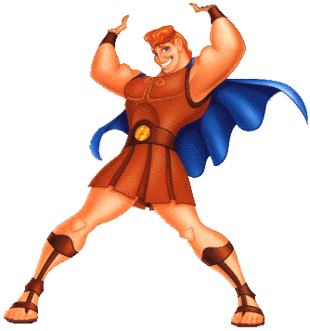
- You can do it!!! Work hard and stay focused… summer will be here before you know it—but work hard all the way till the end
A+
Science final

