What is going on be on the Foundations Physical Science exam on May 30th at 8:30am?!?!?!!?
- Unit 8 – Properties of Matter
  - Physical/Chemical changes and properties
  - Mixtures and pure substances
  - Boyle’s and Charles’s Laws (Gas Laws)
  - Thermal Energy and temperature
- Unit 9 – Atomic Theory and Structure
  - Scientists (Democritus, Dalton, Rutherford, Bohr, etc…)
  - Atomic/Isotope structure (subatomic particles and nuclear notation)
  - Electron Configuration
  - Periodic table families
  - Periodic trends (reactivity, ionization energy, atomic radius)
- Unit 10 - Chemical Bonding & nomenclature
  - Nomenclature rules for ionic and covalent
  - Writing chemical formulas for ionic and covalent
  - Lewis dot structure of compounds
  - Metallic Bonding
- Unit 11 – Chemical Reactions
  - Identifying types of reactions
  - Writing and balancing chemical equations
  - Calculating Molar Mass
  - Solubility
  - Saturated, unsaturated, and supersaturated solutions
  - Rates of Reactions
- Unit 12 – Stars and Astronomy
  - Life cycle of a Star and HR diagrams
- Unit 13 - Nuclear Chemistry
  - 3 Types of Nuclear decay equations
  - Fission/fusion
  - Graphing and solving half-life
- Unit 14 – Acids and Bases
  - Distinguishing between acids and bases
  - Calculating pH

How should I study?!?
- First, start with topics you know you struggle with.
- Look over old tests—but take them over again! Quiz yourself. Don’t just skim over the test and expect to understand your mistakes.
- Redo old homework/practice problems. You’ll have to dust off some old skills we haven’t used in a little while!
- Rewrite old notes. Data suggests that writing things down is more likely to convert them to long term memory instead of just reading them!
- Start early. Set little goals for yourself each day leading up to the final. Starting to review the weekend before the final is way too late! (Although better than nothing…)
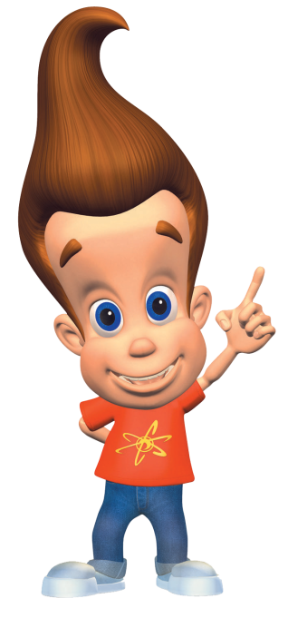
- You can do it!!! Work hard and stay focused… summer will be here before you know it—but work hard all the way till the end
Science final
A+

