Monday 11/13 | Tuesday 11/14 | Wednesday 11/15 | Thursday 11/16 | Friday 11/17
- Heat and Temperature Notes  Homework:  -LearnSmart due by Tuesday@ 11:59  -Temperature conversion ws due Wednesday | -Heating Curves  Homework:  -Temp conversions due tomorrow | -Heating curves activity  Homework:  -finish activity if not done in class | -Heating Curve of water lab  Homework:  - lab due tomorrow | Tower Building Challenge!
Monday 11/27 | Tuesday 11/28 | Wednesday 11/29 | Thursday 11/30 | Friday 12/1
- Calorimetry  Homework:  - Connect due by 11:59 pm Thursday  -Calculations ws due Wednesday | - Calorimetry Cont.  Homework:  - Connect due by 11:59 pm by Thursday  -Calculations ws due Wednesday | - Calorimetry Lab  Homework:  - Finish Lab  - Connect due by 11:59 pm Thursday | -Review for Heat test  Homework:  -study  - Connect due by 11:59 pm Thursday | Heat Test
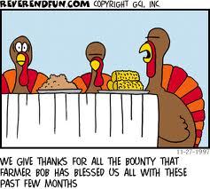
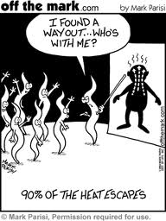
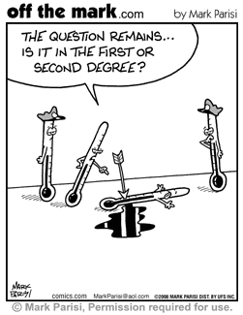
Unit 5 – Heat and Temperature

