HPS – Reflection/Refraction Lab

Name____________________________ Period__________
I can…
Define wave behavior.
Calculate Index of refraction.
Describe interactions of light at wave boundaries.

- Go to shakerscience.weebly.com
- Mouseover “Honors” then click “Unit 6”
- Scroll down all the way to Week 5
- Click “Reflection Refraction Phet Lab”
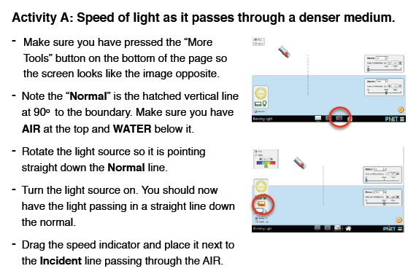
Part A – Speed of Light
- Select “Wave” in the top left corner. Move the light source to make an angle of incidence between 50° & 60°. Press the laser’s button. Sketch an outline of what occurs.
- Select “Angles”. 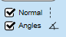  What is the incident angle (original laser), the reflected angle (the lighter beam bouncing off the water) and the refracted angle (the bent beam going into the water)? | Incident_______________  Reflected______________  Refracted______________
- What do you notice about the reflected and the incident angles? Explain why this occurs.

- Describe how the refracted angle differs and explain WHY.
- Grab the green Intensity tool.  Place the viewer over the  incident ray and record the  value, then record the intensity  of the refracted ray.  WHY do you think they differ  the way they do? | 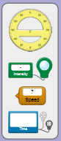  Incident:___________%  Refracted:___________%  They differ this way because…
- Now, place the intensity reader on the reflected ray. WHY do you think they differ  the way they do? | Incident:___________%  Reflected:___________%  They differ this way because…
- Check your notes: what part of the wave (frequency, amplitude, or wavelength) is the intensity AND what does that mean for a light wave?
- Move the green Intensity tool away. Grab the blue Graphing tool. Place one
viewer on the incident ray and one
on the reflected ray.
SKETCH what you see.
- Does the frequency differ, if so how?
- Does the amplitude differ, if so how?
- Leave one viewer on the incident ray and move the other to the refracted ray. SKETCH what you see.
- Describe what you notice.
- Take the orange Speed tool.  Record the speed of the incident,  reflected, and refracted ray. | Incident:___________c (m/s)  Reflected:___________c (m/s)  Refracted:___________c (m/s)
- Using c as 300,000,000m/s, calculate the speed of light of each ray. | Incident:____________________ m/s  Reflected:____________________ m/s  Refracted:____________________ m/s
- Why is the speed of the incident and reflected ray the same?
- Why is the speed of the refracted ray in water is less?
- Leave everything the same, but change the Material to “Water”. Describe what you notice and give an explanation.
- Change the second medium to Mystery A. Write a procedure to solve for the n, index of refraction.
- What is the index of refraction (n)? Use the internet to look up what Mystery A could be. | n = _________________  Mystery A is ___________________________
- Do the same for Mystery B. | n = _________________  Mystery B is ___________________________
- Look up the refractive index of sapphire. Then, solve for the speed of light in a sapphire. Use the formula from your notes.
- Click the “Prisms” tab. Select a triangle glass prism.Select the multiple beam laser.
Turn on the laser and allow it to refract through the prism. Describe your observations of the 2 instances of refraction.
- Toggle to orange, then yellow, then green, blue, then violet. What do you notice about the refraction?
- Seeing this, what relationship can you draw between wavelength of light and refraction?
- Select the white light. Why can you produce a rainbow?

