FPS – Reflection/Refraction Lab

Name____________________________ Period__________

I can…
Define the parts of a wave.
Relate the properties of a wave.

- Go to shakerscience.weebly.com
- Mouseover “Foundations” then click “Unit 5”
- Scroll down all the way to Week 5
- Click “Reflection Refraction Phet Lab”
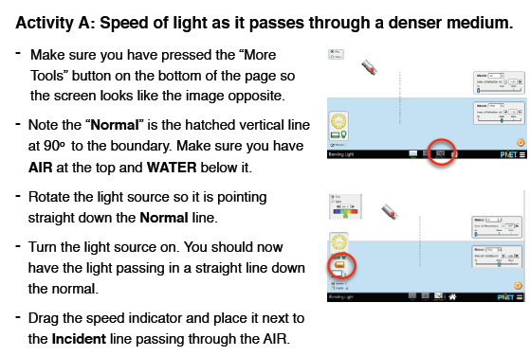
Part A – Speed of Light
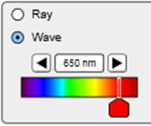
- Select “Wave” in the top left corner. Sketch an outline of what occurs.
- Select “Angles”. 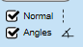  What is the incident angle (original laser), the reflected angle (the lighter beam bouncing off the water) and the refracted angle (the bent bean going into the water)? | Incident_______________  Reflected______________  Refracted______________
- What do you notice about the reflected and the incident angles?

- Describe how the refracted angle differs and try to explain WHY.
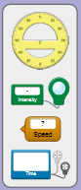  - Grab the green Intensity tool.  Place the viewer over the  incident ray and record the  value, then record the intensity  of the refracted ray.  WHY do you think they differ  the way they do? | Incident:___________%  Refracted:___________%  They differ this way because…
- Now, place the intensity reader on the reflected ray. WHY do you think they differ  the way they do? | Incident:___________%  Reflected:___________%  They differ this way because…
- Check your notes: what part of the wave (frequency, amplitude, or wavelength) is the intensity AND what does that mean for a light wave?
- Move the green Intensity tool away. Grab the blue Graphing tool. Place one
viewer on the incident ray and one
on the reflected ray.
SKETCH what you see.
- Does the frequency differ, if so how?
- Does the amplitude differ, if so how?
- Leav one viewer on the incident ray and move the other to the refracted ray. SKETCH what you see.
- Describe what you notice.
- Take the orange Speed tool.  Record the speed of the incident,  reflected, and refracted ray. | Incident:___________xc (m/s)  Reflected:___________xc (m/s)  Refracted:___________xc (m/s)
- Why do you think the speed of the incident and reflected ray the same?
- Why do you think the speed of the refracted ray in water is less?
- Leave everything the same, but change the Material to “Water”. Describe what you notice.

The Quiz!
Go to http://join.quizizz.com and enter the game pin on the board to get started! Record your score below.

