Rainbow Lab 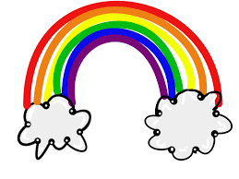
Name: _______________________________________Date:_________
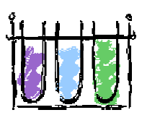
I can…
1. measure chemicals with a graduated cylinder.
2. use the metric system.
3. follow directions.
4. practice lab safety procedures.

Procedure:
Part 1 :
1. Label 6 test tubes in order: A, B, C, D, E & F.
2. Locate your rinse beaker. You will use this to rinse your graduated cylinder.
3. Locate your waste water. You will use this to dispose of contaminated liquid.
4. Into test tube A, measure 25 mL of RED liquid.
5. Into test tube C, measure 17 mL of YELLOW liquid.
6. Into test tube E, measure 21 mL of BLUE liquid.

Part 2:
1. From test tube C, using a pipette, measure 4 mL and pour into test tube D.
2. From test tube E, using a pipette, measure 7 mL and pour into test tube D. Swirl.
3. From test tube E, using a pipette, measure 4 mL and pour into test tube F.
4. From test tube A, using a pipette, measure 7 mL and pour into test tube F. Swirl.
5. From test tube A, using a pipette, measure 8 mL and pour into test tube B.
6. From test tube C, using a pipette, measure 3 mL and pour into test tube B. Swirl.
7. SAVE your results . Measure the contents of each test tube and record how many mL were found in each test tube. You can do this by pouring them back into the graduated cylinder.
8. Answer the questions.

Data Table 1 : Test Tube Results Test Tube
Test tube | Color of Liquid | Amount of Liquid mL
A
B
C
D
E
F
 | Total liquid Test Tubes A-F (add them up) | mL

Analysis/Results:
1. Name the colors that you created (NOT red, blue, or yellow). ______________________________________________________________________________________________________________________________________________________________________________
2. How many mL of liquid were in each test tube at the start of this lab?
Test tube A________________ Test tube C______________ Test tube E_______________
3. Why is it important to follow directions exactly? Use a complete sentence.
______________________________________________________________________________________________________________________________________________________________________________
______________________________________________________________________________________________________________________________________________________________________________
4. What would have happened if your measurements were not correct? ______________________________________________________________________________________________________________________________________________________________________________
5. Look at your hands. Do you have any stains on your hands? If so, those stains represent chemicals that would be on your skin right now! ( yes / no )

6. How many TOTAL mL of liquid did you have at the end of the lab? _________mL
How many should you have? (add up the bold numbers in the procedure) ____________mL
7. What are some reasons why you may have more or less than when you started? _____________________________________________________________________________________________________________________________________________________________________________________________________________________________________________________________________

Conclusion: 2-3 COMPLETE sentences on what you learned.
____________________________________________________________________________________________________________________________________________________________________________________________________________________________________________________________________________________________________________________________________________________________________________________

