Honors Physical Science Course Syllabus
Ms. Perry
Intro: Physical Science course will be graded based on
25% lab reports and projects
20% homework and classwork
25% quizzes
30% tests
Contact: perry_j@shaker.org
Office: 277
www.shakerscience.weebly.com
- E-mail is the best way to contact me with questions after class.
- I will use Remind and our website for reminders and announcements.
- Conferences from 3:00-4:00pm will be held as follows:
Monday | Tuesday | Wednesday | Thursday | Friday
NONE | YOUR CLASS | IB Chemistry I – by appointment ONLY | Drop-in -  YOUR CLASS | Make-Ups and by appointment only
Semester grades will be calculated as follows:
Semester 1= 40%
Semester 2= 40%
Semester Exam= 20%

Grading: 100 – 89.5 ………. A
89.4 – 79.5………. B
79.4 – 69.5………. C
69.4 – 59.5………. D
59.4 & below……. F
Required Materials:
You will receive a virtual textbook. Please come to class prepared with:
- A calculator
- Pen or pencil
- A Binder
Tardiness & Attendance:
This class will follow the Shaker Heights guidelines for attendance and tardiness. Please review these guidelines. Your success in this course is very much dependent on your consistent attendance and punctuality.

Make-up Assignments & Tests:
Students who have missed a test or quiz MUST sign up with Ms. Perry to for a time to take the test. Students are responsible for arranging a time with Ms. Perry (after school or during study halls) to make up the test or quiz. Tests and quizzes not made up within the end of the next unit will result in a zero, unless an agreement is made with Ms. Perry. Assignments when absent can be acquired during conferences, or online at our website. Students who have missed a lab must see Ms. Perry to make up the lab. Each lab is different and will have different options. Students are responsible for arranging a time with Ms. Perry.

Late Work
Late work and retakes will only be accepted before the end of the quarter. After the unit test corresponding to the assignment, the assignment can receive up to 50% credit.

Classroom Expectations & Behavior Requirements
- Plagiarism and cheating will not be tolerated. All students should complete their own work. If copying is suspected, both parties will receive a zero.
- No food or beverages, except water, are allowed in the classroom. Students in the classroom may have allergies and it is critical in a lab space to refrain from eating or drinking.

- Special emphasis will be placed on behavior during lab activities. Behavior that endangers students or lab property will not be tolerated and may result in barring the student from the remaining labs, for which the student will receive a zero without any chance to make up these points. The lab group will replace any broken property that is broken through carelessness. If one or more of your lab partners are not being responsible with the lab equipment, inform me before it is too late. Lab equipment is generally expensive.

- Your participation is valued, and we will all listen, encourage, and interact with other respectfully. This includes speaking in turn using respectful and appropriate language.

- Cell-phone usage is only appropriate when given permission by your instructor. Cell-phones being used without permission will be taken and kept for the remainder of the period. Repeating to use cell-phones inappropriately will result in calls home and cell-phones kept for the day in room 110 with a referral.
Safe Space
This class is a safe space. This means we acknowledge and support all sexual orientations, gender identities and expressions as part of our culture. The expectation is that every student uses language that is appropriate for a professional community of learners. No term, gesture or sound that demeans (intentionally or playfully) a person based on race, gender, sex, sexual orientation, culture or religion, learning ability, physical attributes, economic status and humanity will be tolerated.
The Lab
Safety
Students and parents will sign a safety contract. Students will conduct themselves in the laboratory in a safe and conscientious manner at all times. Groups are assigned to lab areas and may use only the supplies issued at the station. Always follow Ms. Crowley’s and Ms. Perry’s written and spoken instructions. More information will be provided regarding safety and procedures in the lab.

Lab Write-Ups
For every lab, each student will be responsible for a lab write-up. Students are responsible for their own lab write-up and each member of a lab group should have separate and unique write-ups.

Being Successful
The course will cover many topics that build on each other. It is important that students understand they will have to work hard and develop good study skills!

Staying organized will help you keep up with assignments and content. I suggest keeping all physical science assignments in one place – binder, folder, or notebook. SEE ME right away if you would like a binder or folder. I do not check binders, but it is a good idea to keep it in order anyway.
If you find yourself struggling, ask for help sooner than later. Sign up for conferences and go to study circles. Use your instructors, classmates, conferences, and other resources in your school for help.
The concepts will build on each other, so you will need to make sure you understand one concept before moving on. If you work hard, you can be a successful scientist this year. I am excited to get to know you and DO SOME SCIENCE!!!
International Baccalaureate MYP

The International Baccalaureate aims to develop inquiring, knowledgeable and caring young people who help to create a better and more peaceful world through intercultural understanding and respect.

Learner Profile
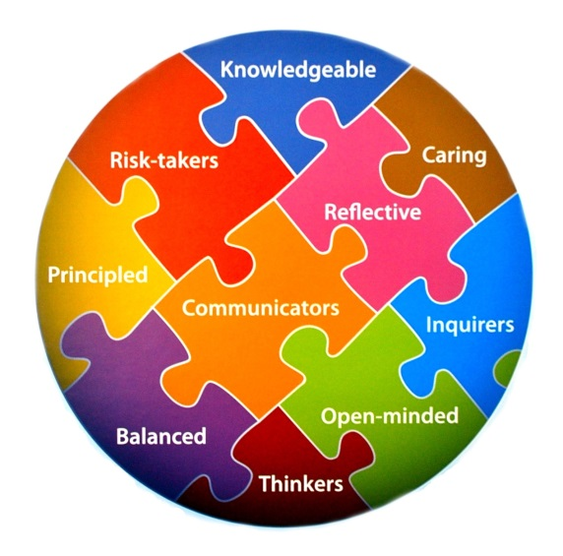
These programmes encourage students across the world to become active, compassionate and lifelong learners who understand that other people, with their differences, can also be right.

We are inquirers, knowledgeable, thinkers,
communicators, principled, open-minded
caring, risk-takers, balanced, and reflective.

Assessed Criteria of MYP

Throughout the course, MYP rubrics will be used, and
it is recommended to get familiar with them early on.
They will be made available several times throughout the course, on the course website,
and upon request. We will be looking at the rubrics together soon.

Restorative Practices
This course will engage in restorative practices. More information on these practices
and their requirements will follow.

STUDENT – GUARDIAN CONSENT FORM

I, _________________________________, have reviewed and agree to adhere to the class rules and
(print student’s name neatly)

expectations set forth by Ms. Perry, as explained in the classroom policies. I also understand that,
if necessary, some of these rules may be susceptible to change, depending on how my class as a
whole, or how I as an individual, perform(s) over period time.

Student’s Signature

Guardian name printed Guardian’s Signature

Please tear off this page from your course syllabus and turn it in by August 30th, 2017.

