Directions: Show ALL of your work. Make sure to include units!!!!

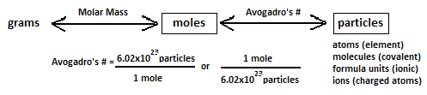
Mole-Particle Conversions (use Avogadro’s number for your conversions)
1. How many moles of magnesium are in 3.01 x 10²² atoms of magnesium?

2. How many glucose molecules are there in 4.00 moles of glucose, C6H12O6?

3. How many moles are 1.20 x 1025 formula units of calcium iodide?

4. How many formula units are in 12.5 moles of calcium phosphate?

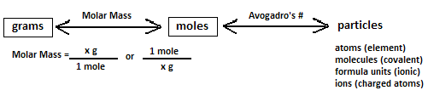
Mole-Mass Conversions (use the molar mass from the periodic table for your conversions)
- How many moles are in 28 grams of CO2 ?

- What is the mass of 5 moles of Fe2O3 ?

- Find the number of moles of argon in 452 g of argon.

4. How many grams are in 3.45 moles of CO₂?

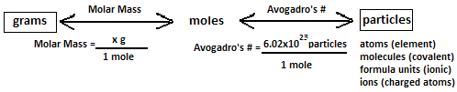
Gram to Particle Conversions (two step conversions using molar mass and Avogadro’s number)
1. How many oxygen molecules are in 3.36 g of oxygen (O₂) [2 x mass of O]?

2. Find the mass in grams of 2.00 x 1023 molecules of F2.

3. Determine the number of molecules of 14 g of nitrogen dioxide (NO₂).

4. Find the mass, in grams, of 1.00 x 1023 molecules of N₂.

5. Aspartame is an artificial sweetener that is 160 times sweeter than sucrose (table sugar) when dissolved in water. It is marketed by G.D. Searle as Nutra Sweet. The molecular formula of aspartame is C14H18N2O5 .

a) Calculate the molar mass of aspartame.

b) How many moles are in 10.5 g of aspartame?

c) How many molecules are in 10.5 g of aspartame?

e) How many atoms of nitrogen are in 1.2 grams of aspartame?

