General Physical Science – Math & Science Skills
Name ________________________________________________ Period _______________
- What place value does 3 have in 4,235,100?

- Which digit is in the thousands place in 4,968,123?

Complete the Following:
3. 46 + 729 + 1025 + 47 = 4. 96 + 321 + 21 =

5. 423 – 69 = 6. 145 x 36 =

7. 980 - 74 - 102 = 8. 396 ÷ 23 =

9. Round 799 to the nearest ten 10. Round 9.249 to the nearest hundredth

11. Round 4,868 to the nearest hundred 12. Round 123 to the nearest hundred

13. Thirty identical chairs cost $1680. What is the cost of one chair?

14. If each cookie at a bake sale costs $0.55, how much does a dozen cost?

15. MiKayla notices her shower is starting to have green mold on the walls. Her friend Elijah suggests she use vinegar to clean the mold off of the shower. MiKayla’s hypothesis is: “If I add vinegar to the mold, then the mold will come off.” MiKayla decides to spray one side of her shower with vinegar, and do nothing to the other side. After one week, the mold is still there on both sides.
a. What is MiKayla’s hypothesis?

b. What is the independent variable that MiKayla changed in her experiment?

c. What should MiKayla conclude about her experiment?

16. Ms. Bauer has a basket of writing tools. Below is the bar graph for these tools.
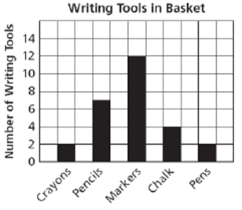
a. Which writing tool(s) does Ms. Bauer have the LEAST amount of?
b. What is the TOTAL amount of writing tools?

17. What is the speed of a dog that runs 50 meters in 2 seconds? (Try using the Equation Triangle)
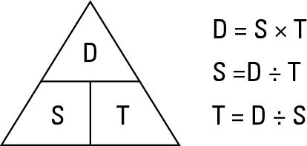
18. What is the distance the dog runs if it runs for 40 seconds at a speed of 4 meters per second?

