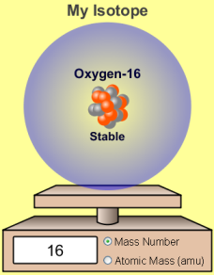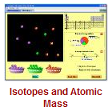**Intro to Isotopes PhET Lab**

**Introduction:** Breath in…Breath out. Again! When you inhale air, you are not just inhaling a mixture of oxygen, nitrogen, and trace gasses, but a mixture of different oxygen atoms and different nitrogen atoms. It turns out that all oxygen atoms have the same number of protons, but some may have different numbers of neutrons. These different-but-still-oxygen atoms are called isotopes. Some atoms have just two isotopes; some have dozens!

**Some handy vocabulary for you to define:**

Proton ________________________________________________________________________________________________

Neutron _______________________________________________________________________________________________

Isotope ________________________________________________________________________________________________

Atomic Mass ___________________________________________________________________________________________

Radioactive ____________________________________________________________________________________________

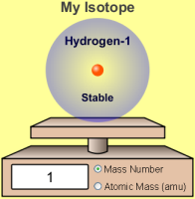Natural Abundance ______________________________________________________________________________________

**Procedure:** PhET🡪*Play with the Sims 🡪 Chemistry 🡪 Isotopes and Atomic Mass* 

* Take some time and play with the simulation. Imagine you are manipulating atoms! EXCITING!
* Be sure to activate  and 

1. How do the number of protons change as atomic number increase by one? _____________________________________
2. How does the mass of the atoms change as atomic number increases by one? ___________________________________
3. What effect does adding a neutron have on the atom’s **identity**? ______________________________________________
4. What effect does adding a neutron have on the atom’s **mass**? ________________________________________________
5. **Draw the nucleus of the most abundant isotope** of each of the following atoms in the boxes below. Be sure to count and label the protons and neutrons.
6. Also **show the full atomic symbol**. Hydrogen has been done for you. 

**Hydrogen: H Carbon: C Oxygen: O Neon: Ne**

|  |  |  |  |
| --- | --- | --- | --- |
|  |  |  |  |

Complete the chart below. In some cases, you will need to work backwards to fill out missing information.

|  |  |  |  |  |  |  |
| --- | --- | --- | --- | --- | --- | --- |
| Isotope Name | Atomic Number | # of Protons | # of Neutrons | Mass Number | Stable?  (Y/N) | Ratio of neutrons to protons |
| **Hydrogen-2** |  |  |  |  |  |  |
| **Helium-3** |  |  |  |  |  |  |
| **Helium- 4** | 2 |  |  | 5 |  |  |
| **Lithium-6** |  |  |  |  |  |  |
|  | 3 | 3 | 4 | 7 |  |  |
| **Oxygen-16** |  |  |  |  |  |  |
| **Oxygen-17** |  |  |  |  |  |  |
|  |  | 8 | 10 | 18 |  |  |
|  |  | 10 |  | 20 |  |  |
| **Neon-23** |  |  |  |  |  |  |

**Analysis Questions** *You may need to use the internet to define some terms.*

1. Water is H2O. How many isotopes of hydrogen exist in nature? (even unstable ones) ____________
2. Use the internet to search for “heavy water.” What is this stuff? ______________________________________________

___________________________________________________________________________________________________

1. How does it behave, compared to ordinary water? _________________________________________________________

___________________________________________________________________________________________________

1. Does heavy water’s ice float or sink in ordinary water? ___________ Why? _____________________________________

___________________________________________________________________________________________________

1. Observe the atoms you determined to be unstable. What can you conclude about the ratio of neutrons to protons and a nucleus’ stability? ___________________________________________________________________________________
2. What makes Carbon-14 so useful in “carbon dating” or “radio dating”? ___________________________________________________________________________________________________
3. Could a stable isotope of carbon be used in the same way? ____________ Why or why not? ___________________________________________________________________________________________________