Lab: Acids, Bases, & pH Name:________________________________
Objective: Use litmus paper to determine if a variety of solutions are acids or bases. Use pH paper and litmus paper to determine the pH of the solutions.
Background Info:
Litmus paper can be used to determine if a solution is an acid or a base.
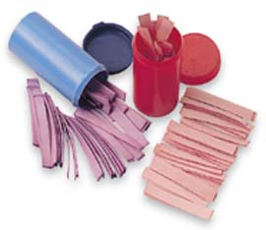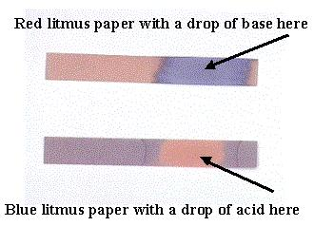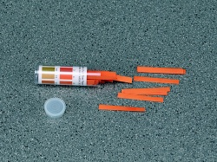
Acid = blue litmus paper turns _________________
Base = red litmus paper turns __________________
Neutral = blue litmus stays blue, red litmus stays red
pH scale = scale from 0 (most ______________) to 14 (most _________________). 7 neutral
pH paper = used to determine pH

Hypothesis: Make predictions below.
Solution | Acid (A) or Base (B)?
Distilled Water
Coca-Cola
Ammonia (diluted)
Bleach (diluted)
Milk
Maalox
Vinegar
Orange Juice
Baking Soda (in water)
Procedure and Materials:
Materials:
- red and blue litmus paper (5 of each, then tear in half)
- pH paper (5, tear in half)
- forceps
- plastic 10 mL wells
- Listed solutions at each station
- Paper towel at each station
- Goggles and apron

Procedure:
- Go to one of the stations and put ~10 drops of the solution into three of the plastic wells.
- Test each of the solutions with red and blue litmus paper to determine if the solution is an acid, base, or neutral. Use the forceps to dip the litmus paper. After you dip it, place the litmus paper on the paper towel at the station. Record your results. EACH LITMUS PAPER CAN ONLY BE DIPPED INTO 1 SOLUTION, ONCE.
- Test each of the solutions with pH paper to determine its pH. Use the forceps to dip the pH paper. After you dip it, place the pH paper on the paper towel. Compare the color to the color chart on the container to determine the pH. Record your results. EACH pH PAPER CAN ONLY BE DIPPED INTO 1 SOLUTION, ONCE.
- Dump and rinse the plastic wells in the sink. Dispose of papers in trash.
- Repeat steps 1-4 for the other stations. Do not leave a mess behind you!
Data:
Solution | Red litmus | Blue litmus | Acid or Base? | pH using pH paper
Water
Coca-Cola
Ammonia (diluted)
Bleach (diluted)
Milk
Maalox
Vinegar
Orange Juice
Baking Soda (in water)

Analysis Questions:
ACIDS | BASES | NEUTRAL
- Fill in the following table by listing which substances were acids, bases, or neutral.

- How can you determine the strength of an acid or base?

- Discuss the advantages and disadvantages or litmus paper and pH paper.

- Which indicator do you think is the best, and why?

- You may have seen commercials on TV for Nexium, a drug that is taken to reduce the symptoms of acid reflux disease. Knowing that this condition is caused by too much acid in the stomach,
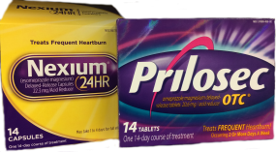
  - Do you think Nexium would be an acid or a base?

  - How would you test it to find out?

  - Explain how you think it works to relieve problems caused by too much acid.

