Name ________________________________
Observing the Heating Curve of Water

SAFETY: You must wear safety goggles throughout this lab. Be very careful with the heated water and with the hot plate.
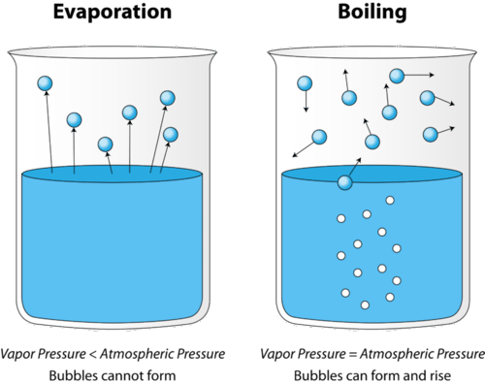
Materials: 400 mL beaker, ice, water, stirring rod, thermometer, stopwatch

Procedure:
- Take the mass of your empty beaker. _______________g
- Plug in, but do not turn on your hot plate.
- Fill the beaker ¾ full with ice.
- Take the mass of ice + beaker. ________g
- Record the temperature of the ice. Do not touch the beaker with the thermometer. __________ºC
- Turn on your hot plate to high. (Be very careful, it will heat up quickly.)
- Insert the thermometer into the ice, making sure that the bulb of the thermometer is covered but NOT on the bottom of the beaker.
- Place the beaker on the hot plate.
- Record the temperature of the water every 30 seconds in the data table.
- Once the water begins to fully boil (check with your teacher), record the temperature every 30 seconds for three more minutes, time permitting.
- Turn off the hot plate, but leave the beaker on the hot plate to cool.

Data Table:
Time (s) | 0 | 30 | 60 | 90 | 120 | 150 | 180 | 210 | 240 | 270 | 300
Temp (°C)
Time (s) | 330 | 360 | 390 | 420 | 450 | 480 | 510 | 540 | 570 | 600 | 630
Temp (°C)
Time (s) | 660 | 690 | 720 | 750 | 780 | 810 | 840 | 870 | 900 | 930 | 960
Temp (°C)

Analysis:
Make a graph of the temperature of the water vs. time in seconds using the graph paper. Put the temperature on the y-axis and the time on the x-axis. Be sure to label each axis and give the units for each. Connect the data points. Make sure you use a consistent scale!!!

Questions:
- What is the boiling point of water according to your data?
- What do you notice about the change in temperature of the water when the water began to boil?
- Which has more heat energy, a gram of water at 100 °C or a gram of steam at 100°C?
- Find ΔT by finding the difference between initial and final (boiling) temperature. Plug into the formula below:
  - ΔT = T_{f} - T_{i}
ΔT = ( - )
ΔT =
- Find the mass of just the original solid water sample.
  - Mass H₂O = Mass of beaker + H₂O - Mass of beaker
Mass H₂O =
- Using the formula Q = mc ΔT, with Q as heat, m as mass, and c as specific heat (the heat required to raise the temperature of the unit mass of a given substance by usually one degree) and ΔT as change in temperature, find the heat (with UNITS) if the specific heat of water is 4.184 J/g ºC.

Q = mc ΔT
Q = ( ) (4.184 J/g ºC) ( )
Q =

- If the heat released were -12,000J (notice the NEGATIVE value), the mass of the water were 303g, initial temperature were 89 ºC and the specific heat were the same, what would the final temperature be? Show ALL calculations and circle final answer.

