Graphing Multiple trend-lines in excel

- Start Microsoft office Excel
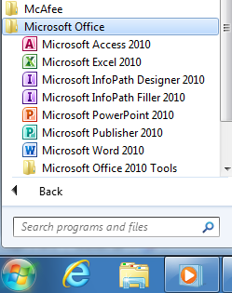
- Put in your data from Bubble Tube Lab (Average time and Distance) are shown below.
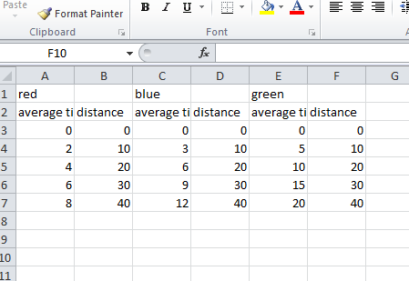
- DON’T select any data, and go to Insert Charts Scatter. You’ll have a weird blank box.
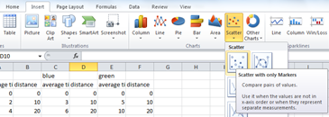
- Right click the white box, and click “Select Data”
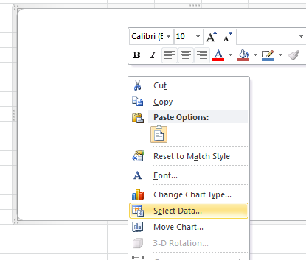
- Click the “Add” button
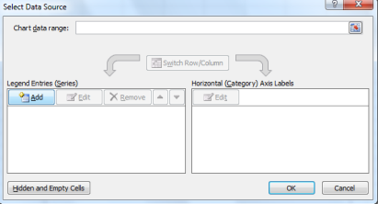
- Name the series. Click in Series X values box and highlight the times, then click in the Y box (making sure to delete anything already there) and highlight the distance.
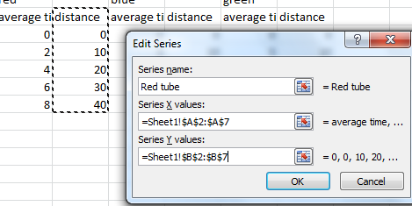
- Right click on a set of points, and select “Add trendline”
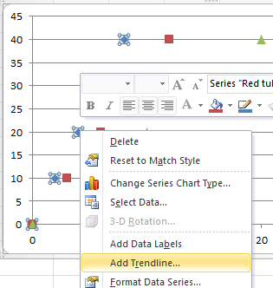
- Select linear, and check the box that says “Display equation”
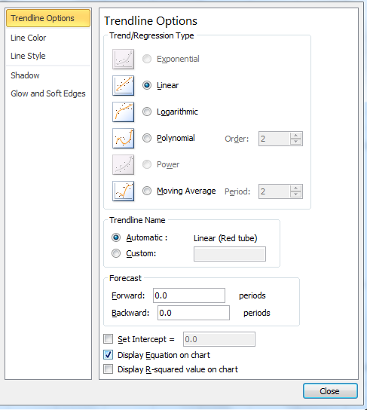
- Do this for all 3 lines. Then copy and paste the graph into a word document. Format the word document as a lab report (appropriate heading and title) and Explain your results. (Hint: use the analysis questions 1-6 on the lab.)

