Name
Date:_____________

Motion Graphs

Data set 1
Time Distance
(Hours) (miles)
1 9
2 12
3 15
4 18
5 21
6 24

Explain the motion of the object in words:

Questions
a. Where did the object start?

b. How fast is the object going? In what direction?

Create a Velocity vs time graph from the information above

c. After 10 hours of travel where would the object be?

Data set 2

Time Distance
(min.) (meters)
1 27
3 21
4 18
6 12
8 6

Explain the motion of the object in words:

Questions
a. Where did the object start?

b. How fast is the object going? In what direction?

Create a velocity vs time graph from the information above

c. After 10 min. of travel where would the object be?

Data set 3

Time Distance
(Seconds) (meters)
1 3
2 0
4 6
6 12
7 15

Explain the motion of the object in words:

Questions
a. Where did the object start?

b. How fast is the object going? In what direction?

Create a velocity vs time graph from the information above

c. After 10 seconds of travel where would the object be?

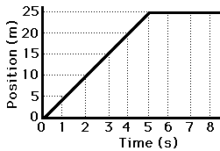
Using the d vs. t graph, create a v vs. t graph.

Explain the motion of this object in words:

The y-axis represents position in meters and the x-axis represents time in seconds.

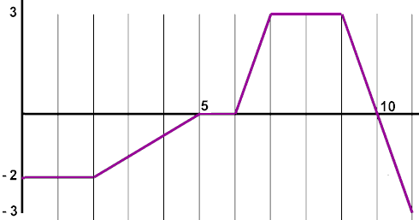

During which intervals was he traveling in a positive direction? ________________
During which intervals was he traveling in a negative direction? ________________
During which interval was he resting in a negative location? ________________
During which interval was he resting in a positive location? ________________
During which two intervals did he travel at the same speed? ________________
During which interval was he traveling the fastest? ________________
During which interval was he traveling his slowest but was still moving? ________________

