GPS – Scientific Method

Name____________________________ Period__________

I can…
Define and list the steps to the scientific method.
Construct and evaluate a hypothesis.

Scientific Method
BELLWORK – What is an observation? Make an observation with a neighbor right now.  ______________________________________  ______________________________________ | 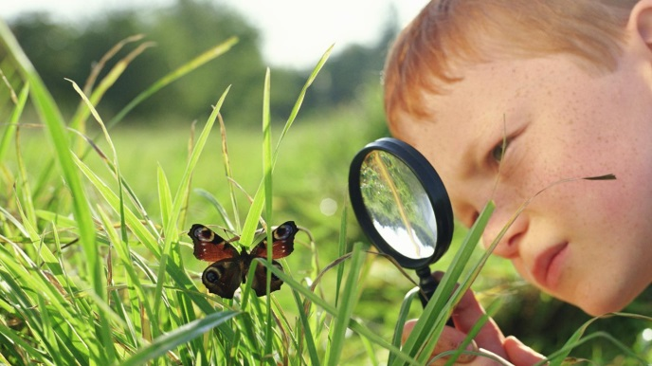
- Which is heavier, the block or the cylinder? Discuss with a partner what you think and WHY.
____________________________________________________________________
- We just used ______________________________ to gather data, and created an ______________________________ to test our _________________________!
- The video will review the steps of the scientific method. He will list them more than once. Record them below.
____________________________________________________________________
____________________________________________________________________
____________________________________________________________________
____________________________________________________________________
____________________________________________________________________
____________________________________________________________________
- We’re going to make some hypotheses of our own. But first… Let’s take some scientific method SELFIES.
-S ________________________________________________
-E_________________________________________________
-L_________________________________________________
-F_________________________________________________
-I_________________________________________________
-E________________________________________________
-S________________________________________________

- Let’s create some hypotheses using limited data. The Bucket of Fate has some objects in it. You may use ONE sense, NOT sight. Can we guess what’s inside?
Hypothesis: _________________________________________________________
With two senses now…
Hypothesis:__________________________________________________________
Three…
Hypothesis:__________________________________________________________
Okay, look inside!
What’s in there?

Recap: why is the scientific method important?
____________________________________________________________________

Experimental Design
- What is a variable?
____________________________________________________________________
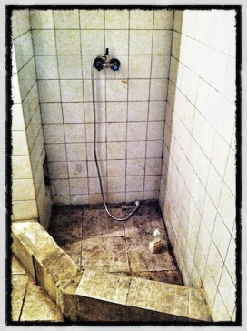
- Let’s look at an example of a simple experimental design. MiKayla notices her shower is starting to have green mold on the walls. Her friend Jacob suggests she use vinegar to clean the mold off of the shower. MiKayla’s hypothesis is: “If I add vinegar to the mold, then the mold will come off.” MiKayla decides to spray one side of her shower with vinegar, and do nothing to the other side. After one week, the mold is still there on both sides.
a. What is MiKayla’s hypothesis?

b. What is the independent variable that MiKayla changes?

c. What should MiKayla conclude about her experiment?

