GPS – Density Group practice

Names______________________________________________________ Period__________
I can…
Calculate densities.
Predict the behavior of a material in a fluid.
In your groups, complete each section below. Each person in your group must be the recorder at least once. Write their name in the box for each section. You must all work together to complete each section. Get a teacher’s initials in the box to move on.
Section 1- Recorder Name:_________________________
Write the formula for work and power and fill in the triangles.
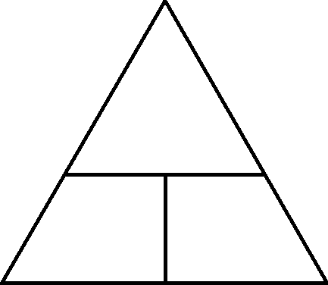

What units do we measure work with? What units do we measure power with?

Who is the unit for work named after?

Who is the unit for power name after?

Section 2- Recorder Name:_________________________

In science, what is the definition of work?

Say WHY or WHY NOT a father carrying a baby from room to room is work.

Say WHY or WHY NOT a mouse pushing a piece of cheese with his nose is work.

Say WHY or WHY NOT a body builder lifting 350 pounds above his head is work.

Say WHY or WHY NOT a scientist giving a speech to an audience is work.

Say WHY or WHY NOT a student pushing a cart across the room is work.

Section 3- Recorder Name:_________________________

Refer to the triangle. Calculate the work done if a child pushes a rock 5 meters with a force of 15 N.
Refer to the triangle. Calculate the force applied if a man does 60 J of work over a 10 meter distance.

Refer to the triangle. Calculate the distance traveled if a dog pulls with a force of 10 N while doing 60 J of work.

Refer to the triangle. Calculate the work done if a woman lifts with a force of 50 N over a 5 meter distance.

Section 4- Recorder Name:_________________________

What is the scientific definition of power.

Refer to your triangle. What is the power output when a cat does 100 J of work over a 3600 second time to catch a mouse?

Refer to your triangle. What is the work done when a boat has a power output of 30 watts for 50 seconds?

Refer to your triangle. What is the time it takes for a car with a power output of 400 watts to do 200 J of work?

Refer to your triangle. What is the power needed to do 40 J or work in 2000 seconds?

