GPS – Stars Mini-Lesson notes

Name____________________________ Period__________
Bellwork
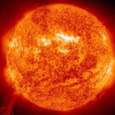 | - Describe 3 things you already know about stars.
- What are stars?
  - A star is a large mass that is composed of hot ______________ that emits __________________; the sun is a typical star.
  - The Sun, our closest star, is 93 million miles from Earth.
( _______________ kilometers)
  - The next closest star is _______________________.
  - By mass, the Sun is ______ % Hydrogen, _____% helium and the rest heavier elements. This is similar to the composition of the __________________.
  - The Sun is about ____________________ years old.
- Sun’s Energy
a. The Sun, like all stars, are driven by nuclear fusion reactions.
b. The core of a star is extremely _______, extremely __________, and under extreme ______________________.
c. Nuclear _________________ takes place in the core of a star.
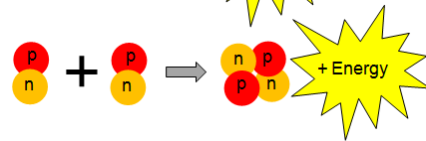
d. The Sun’s nuclear fusion combines the nuclei of _________________ atoms to form ____________________ atoms.

- Stellar equilibrium The Sun is in stellar equilibrium. The inward force of __________________ is balanced by the outward force of ___________ pressure caused by the Sun’s high core Temperature.

- What is a light-year?
A light-year is how astronomers measure ___________________ in space. It’s defined by how far a beam of _____________ travels in one-year—a distance of six trillion miles!

- H-R Diagram (Hertzsprung-Russell)

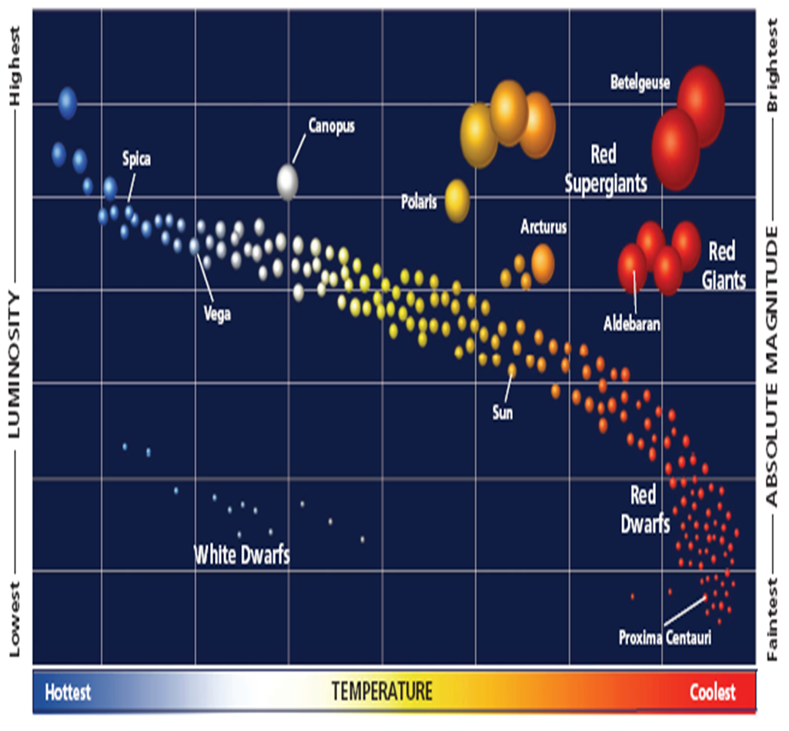

Nebula
ProtoStar
Main Sequence
Giants
Super Nova
White Dwarf
Black Dwarf
Neutron Star
Black Hole

- Draw the Life Cycle of our Sun.

- Draw the Life Cycle of a Massive Star.

- Use the following terms to complete the following: White Dwarfs, Main sequence, Red giants.
