GPS – Solubility

Name____________________________ Period__________
Bellwork
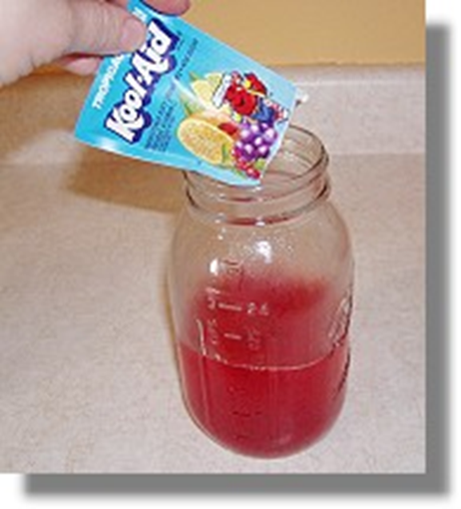 | - What do you remember about the difference between homogeneous mixtures and heterogeneous mixtures?
- A _______________________ is a combination of two or more substances that are not __________________________ combined and can be separated.
- A homogeneous mixture is _______________________ in appearance.
Example: __________________________________
- A heterogeneous mixture consists of visibly ___________________________ substances.
Example:____________________________________________
- Solutions are a group of _________________________ that are mixed up in a complete _________________ distribution.
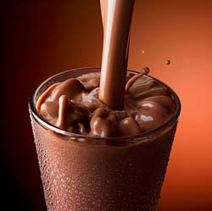
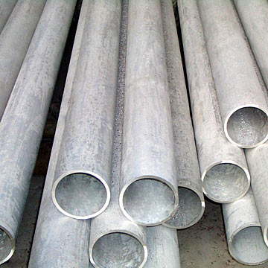
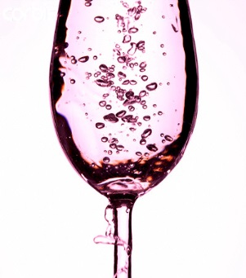
  - Examples below
Chocolate
milk
Alloys
Carbonated
water
- There are two parts in a solution.

  - The _____________________ is the substance that is ________________
Example: salt, sugar, Kool-aid powder
  - The _____________________ is the substance that is DOING the dissolving.
Example: __________________________

- Solubility is the ________________________ of the solvent to _________________ the solute.

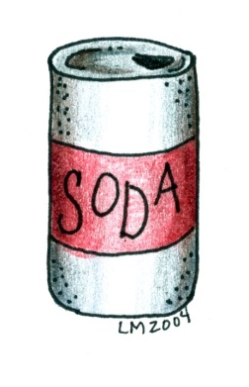
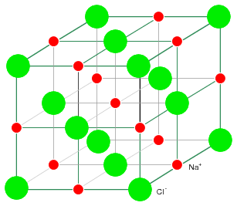
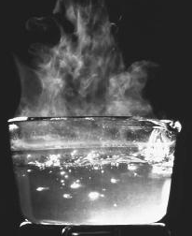
  - What factors affect solubility?

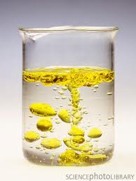
- Describing solubility and solutions
  - Miscible when 2 liquids _______________________
  - Immiscible when 2 liquids DO NOT _____________________
- We can also classify solutions based on amount of solute.
  - Unsaturated solutions have ________________ than the maximum amount of solute _____________________ in them. (This means more could be added, and the solute would continue to dissolve!)
  - Saturated solutions have the ______________________ amount of solute in them. No more can be made to dissolve.
  - Supersaturated solutions have ____________ than the maximum amount of solute in them. This is not possible for all solutions!
Complete the following directed reading independently, using your notes and your book!

