Name:__________________________________________________________ Period:______________
GPS – Quiz 2 – Density study guide
Vocabulary
Define mass.

Define volume.

Define density.

Water
What is the density of water? ____________________g/ml
What happens when an object has a density of LESS THAN 1… | What happens when an object has a density of MORE THAN 1…
Solving
Using the formula or the triangle, solve the following problems. REMEMBER YOUR UNITS!!! Use the table for help.
Mass | Grams (g)
Volume | Milliliter (mL) or  Cubic centimeter (cm³)
Density | g/ml or g/cm³
- What is the density of a cube with a volume of 30 cm³ and a mass of 200 g?
- What is the density of a sample of oil that has a mass of 92 g and a volume of 100 mL?
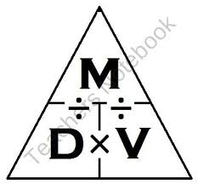
- What is the volume of a cube that has a mass of 40g and a density of 0.93 g/ml?
- What is the mass of a pebble that has a density of 12 g/cm³ and a volume of 2cm³?
- For questions 1-4, write whether the object will sink or float in water.
1.___________________ 2.___________________ 3.________________ 4._______________

