GPS – Rate of reaction intro

Name____________________________ Period__________
Bellwork
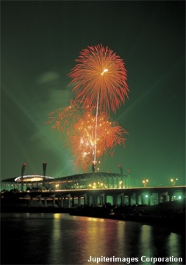 | - Do all reactions happen at the same speed?
- What does a “rate of reaction” mean?
  - The speed of different chemical reactions varies hugely. Some reactions are very ________ and others are very __________.
  - The speed of a reaction is called the _________ of the reaction.
  - What is the rate of these reactions?
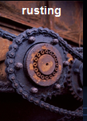 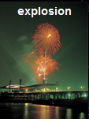

- Rates of Reaction
  - A chemical reaction involves a ________________________ between particles.
  - The particles collide and make ____________________________________.
  - The original particles which react are called the _________________________.
  - The substances which are made or produced are called the _________________________.
- Reactions, particles and collisions
Reactions take place when particles collide with a certain amount of ___________.
  - The rate of reaction depends on two things:
∙ the _____________________________ of collisions between particles
∙the _______________________ with which particles collide.
  - The minimum amount of energy needed for the particles to react is called the ________________________________, and is different for each reaction.
  - If particles collide with _______________ energy than the activation energy, they will _______ _____________. The particles will just bounce off of each other.

- Changing the rate of reactions

  - Anything that _____________ the number of successful collisions between reactants will speed up a reaction.
  - What factors affect the rate of reactions?
∙ increased _______________________
∙ increased _______________________ of reactants or pressure of gases
∙ increased _____________ __________ of solid reactants
∙ use of a _______________________

Work now on the directed readings.

