General Physical Science – Quiz Source 2

Name____________________________ Period__________

Measurement
Unit

 | Measures | SI Unit
Speed
Velocity
Acceleration

Measures
Distance
Displacement
Motion

A vector is…

$Speed= \frac{distance}{time}$
$$Velocity= \frac{distance}{time}$$ and direction

Graph | What it means
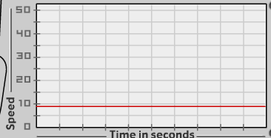
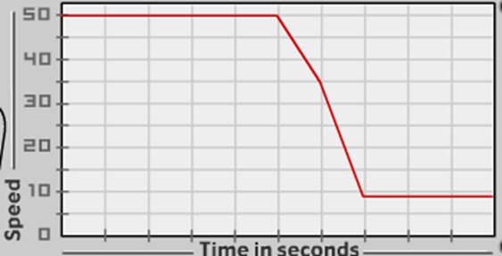
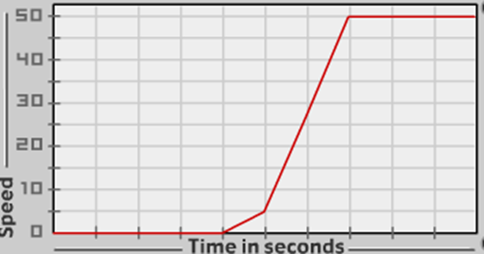

Bar Graph
Dogs | 3
Cats | 6

Line Graph
0 cm | 0 week
3 cm | 1 week
9 cm | 2 weeks

