General Physical Science – Quiz 3 Study guide

Name____________________________ Period__________

 | Measures | SI Unit
Speed
Velocity
Acceleration

Graph | What is the acceleration
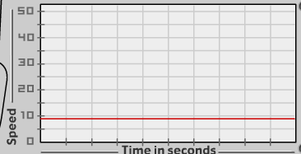
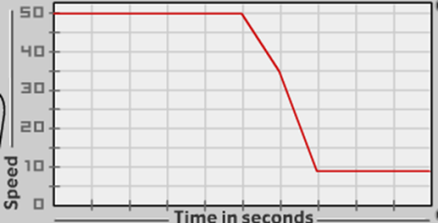
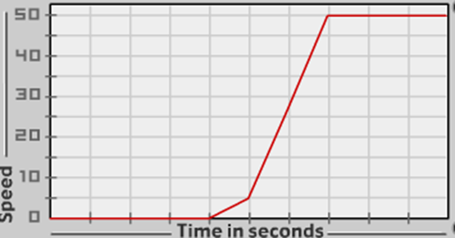

Fill –in problems – answer the questions or define the terms.

- What are the 3 ways an object can have acceleration?

- What is an example of acceleration through ONLY changing speed?

- What is an example of acceleration through ONLY changing direction?
- What is an example of acceleration through both speed and direction?
- How does a rollercoaster accelerate?
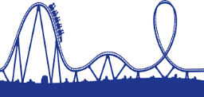

- What does positive acceleration mean?
- What does negative acceleration mean?
- What two things in a car can change your acceleration by changing the speed?
- What can change your acceleration by changing the direction in a car?

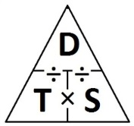
$Speed= \frac{distance}{time}$ $a=\frac{(vf-vi)}{t}$ and direction
$$Velocity= \frac{distance}{time}$$ and direction

Practice problems:

- A dog runs 20 meters in 30 seconds. What is its speed?
- What is your velocity if you walk 300 meters south to school and it takes you 3,600 seconds?
- How long does it take you to walk 70 meters at a speed of 30 meters per second?
- How far will you drive if you are in a car that is going a speed of 40 meters per second for 2,000 seconds?
- A flock of birds is initially flying south for the winter at 10 m/s. By the end of their journey they have slowed to only 1 m/s. The change in speed takes a total of 200 seconds. What is their acceleration?

- You are running westward at 10 m/s, and you come to a sudden stop after 90 seconds. What is your acceleration?
- Your dog is laying down at rest. He begins running and reaches a final velocity of 2 m/s. It takes him 14 seconds to reach that speed. What is his acceleration?
- A cat is initially running 12 meters south and it takes her 6 seconds. She speeds up to 4 m/s when she is chased by a dog. The change in speed takes a total of 10 seconds. What is her acceleration?
Given: Unknown:
Step 1: Find the speed of vi
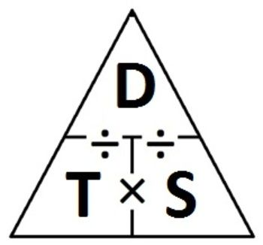
Step 2: Find a
$a=\frac{(vf-vi)}{t}=$
Write the acceleration by including direction:

