General Physical Science – Quiz 3 Study guide

Name____________________________ Period__________

Measurement
Unit

 | Measures | SI Unit
Speed
Velocity
Acceleration

Measures
Distance
Displacement
Motion

A vector is…

$Speed= \frac{distance}{time}$
$$Velocity= \frac{distance}{time}$$ and direction

Graph | What it means
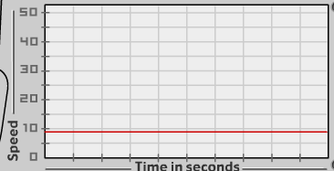
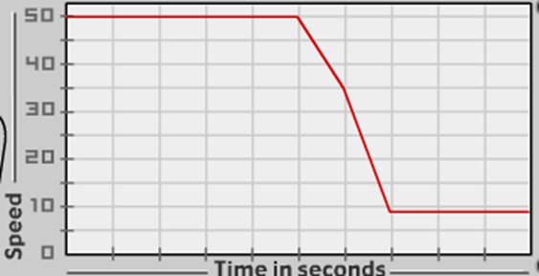
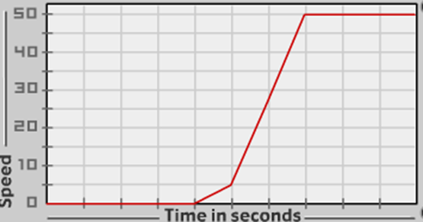

Practice problems:

- A dog runs 20 meters in 30 seconds. What is its speed?
- A bird flies northbound 1,600 meters in 7,200 seconds. What is its velocity?
- What is your velocity if you walk 300 meters south to school and it takes you 3,600 seconds?
- What is the time it takes you to walk 70 meters at a speed of 30 meters per second?
- How far will you drive if you are in a car that is going a speed of 40 meters per second for 2,000 seconds?
- You live 6,000 meters away from the doctor’s office. Your house is west from the office, and it takes you 4,120 seconds to get there. What is your velocity?

