GPS – Properties and Atoms Intro Notes

Name____________________________ Period__________

I can…
Define the parts of an atom.
Distinguish between properties of a substance.

Notes
Bellwork: Write down three examples of any elements you remember.

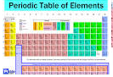
- Elements

- Basic building blocks of _____________.
- Combine to form all ____________ of matter.
- ____________ be broken into ____________________________.
- More than ____________ elements.
- Most are ________________.

- Physical properties of metals
- Conduct _________________ and ____________________
- Shiny (__________________)
- Bendable (__________________________)
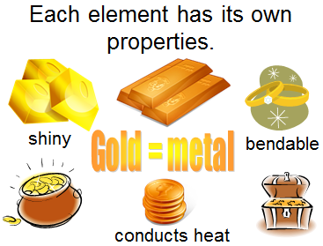

- Fill in the chart below.

- Atom

- The ___________________________________ of an element that still has the
_________________________ of that element.

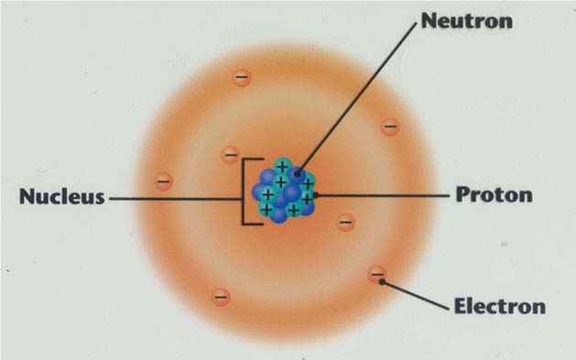

- Compound
- Made of ________________________ of elements.
- ____________________________ of compounds often ________________
from the properties of _____________________ that make them up.

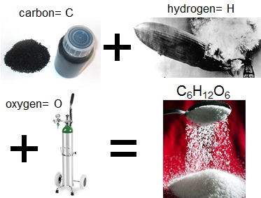

- Ex: C₆H₁₂O₆ = _________________________ (sugar)
- 6 _____________________ atoms
- 12 _____________________ atoms
- 6 _____________________ atoms

- Atomic Theory – The beginning

Democritus believed that the tiniest particle was the atom, which was the smallest thing that could ____________________________________.
He also thought that atoms were made of a _________________________________ that formed into different shapes and sizes.

- John Dalton’s Atomic Theory
Based on scientific ___________________________ through __________________, John Dalton published a theory in 1803. His theory states these ideas:

- All substances are made of ________________. Atoms are small particles that cannot be ________________, __________________, or _________________________.
- Atoms of the same element are ________________________________. and the atoms of different elements are ___________________________.
- Atoms join with other atoms to make ______________________________.
- Disagreeing with Dalton

As scientists were able to gather new data, more discoveries about the atom showed some mistakes with Dalton’s theory.

J. J. Thompson discovered with a __________________________ that atoms contained ___________________-charged particles called ___________________. He came up with the ______________________________ model.

- Rutherford’s Atomic Discoveries

Later, one of Thompson’s students named Ernest Rutherford discovered the ________________________-charged particles in the center of the atom.

- Bohr’s Model and Modern Theory

With more experiments and evidence, Niels Bohr developed his model named after himself, called the ________________ model.

This model represents a small, positively-charged __________________ surrounded by _____________________ that travel in ___________________________ around the nucleus.
Modern Theory developed by scientists, especially Schrodinger and Heisenberg, states that electrons are found in probable ___________________ called ____________________________________.

Atom Building Pre-Lab
- Sketch an atom with 2 neutrons, 2 protons, and 2 electrons. Label the charges of each particle also.

- Pick between Democritus model, Thompson’s model, and the modern Bohr model of the atom. Write your choice below.

- You will build an atom tomorrow. Sketch and describe your materials and procedure for building the model.

