GPS – Practice quiz – Motion
Name:_______________________________________________ Partner:_________________________________
Match the terms with the appropriate definition.
______1. Reference point | - Measurement that requires both magnitude and direction
______2. Relative motion | - The length of the total path travelled
______3. Distance | - The straight line from the change of initial position to final position
______4. Displacement | - Measurement that does not require direction
______5. Vector | - An object that is use to determine motion because it is not moving (eg.: tree outside of a moving car)
______6. Scalar | - Movement in relation to reference point; object changing position over time

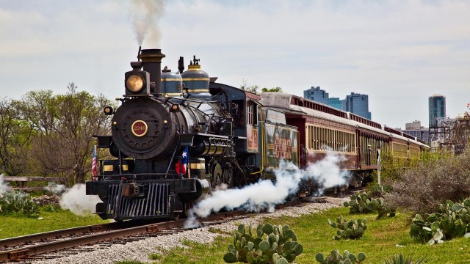
7. A) What is a possible reference point in the image above?
B) Describe why the trees might be a good reference point.
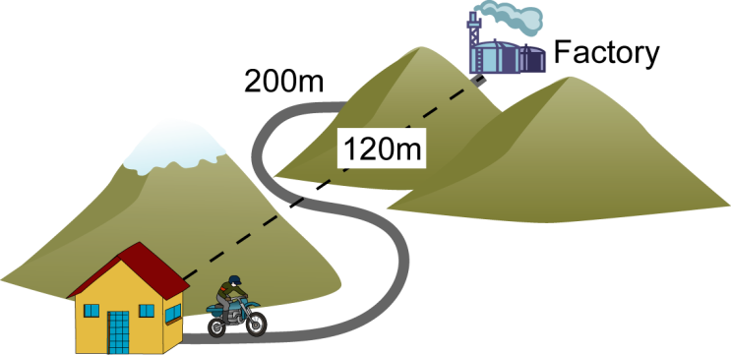
8. See the image above. A) What is the total distance travelled? _________________
B) What is the displacement? __________________________
C) How do you know which is distance and which is the displacement?
9. Explain the difference between speed and velocity.
____________________________________________________________________________________________
____________________________________________________________________________________________
____________________________________________________________________________________________
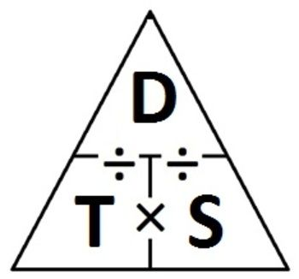
10. The fastest train on Earth can travel 1,408,000 meters in 9,000 seconds. What is the speed of the train? SHOW YOUR WORK.

11. A dog runs at a velocity of 6.1 m/s north. If the dog runs for 200 seconds, how far did it run?

12. Write “true” or “false” for the following statements. REWRITE the false statements to make them true.

_____________ Speed is velocity in a given direction.
__________________________________________________________________________________________________
_____________ The speed of a plane can be described as 300 m/s.
__________________________________________________________________________________________________
_____________ The velocity of a car can be described as 60 m/s to the north.
__________________________________________________________________________________________________
_____________ Speed is a vector.
__________________________________________________________________________________________________
_____________ Velocity is a vector.
__________________________________________________________________________________________________
_____________ For a moving object, the best reference points should be standing still.
__________________________________________________________________________________________________
_____________ Displacement is the total path travelled, while distance is the change from intial to final position.
__________________________________________________________________________________________________

