General Physical Science – Testing Density

Name____________________________ Period__________

I can…
Predict densities.
Observe densities of varying materials.
Explain the relationship between density, mass, and volume.
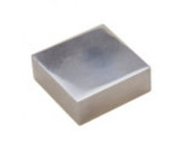
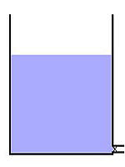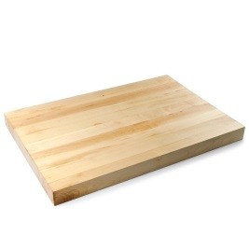

Vocabulary term
Mass
Volume
From the video, record the definitions for the 2 vocabulary words in the boxes to the right.
- We are going to look at different materials’ behavior in fluid. There are two blocks. Predict what materials you think they are made of. Write it to the right.
- We will drop the larger block in the fluid. Predict what you think will happen. Write it to the right. Compare your prediction with a neighbor.
- WHY do you think this will happen? Write your explanation to the right.
- Observe what happened. Record your observations to the right.
- We will drop the other block into the fluid. Predict what you think will happen. Record it to the right. Share your prediction with a neighbor.
- Observe what happened. Record your observations to the right.

- Let’s explain what happened. Pair with a partner and try to write an explanation for what you observed. (Hint: use words like mass, volume, or density.)
- Let’s check our explanations. Rewrite our class explanation to the right.
- An object’s density affects its behavior in a fluid. Write the fluid and density of the fluid we are working with today to the right.
- Write a hypothesis (if… then statement) to further experiment with materials and their densities. | If…  Then…
- Density can be solved using a mathematical relationship between mass and density. Record the relationship.
- Find the densities of the blocks we used today. | 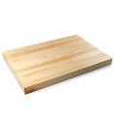  Mass: 100 g  Volume: 200 mL  Mass: 100 g Volume: 37 mL
- A mystery block has a mass of 100g and a volume of 100 mL. Calculate the density. Will it sink or float? Predict with a partner.

Try it on your own on the next page.

Try on Your Own
Try the following problems on your own. Show your work and get an initial from your teacher before moving on!

- Block A has a density of 0.92 g/mL and Block B has a density of 8.7 g/mL. Which one will sink in water? WHY? | Teacher Initial
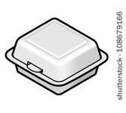
- A brick of Styrofoam has a volume of 10 mL and a mass of 0.2 g. What is the density? Will it sink or float in water?
- Olive oil has a density of 0.92 g/mL. Describe what will happen if you pour oil over water and WHY.

- A mystery brick has a volume of 50 mL and a mass of 600 g. What is the density? Will it sink or float in water?

- You drop two blocks in water. Block A has a volume of 50 mL and a mass of 600 g. Block B has a volume of 50 mL and a mass of 100 g. Calculate their densities. Sketch and label what the set up would look like.

