GPS – Nuclear reactions notes

Name____________________________ Period__________
Bellwork
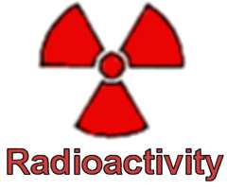 | - Listen to the nuclear decay song, then list 3 things you remember from the song.
- Nuclear Radioactivity:
  - _____________________ compose of protons and neutrons
  - Strong force causes ________________ and ______________________ to be attracted.
  - Powerful only when protons and neutrons are closely _______________ together.
  - Large nucleus is held ___________ tightly than a small nucleus
- Nuclear decay happens when the ___________ _____________ is not large enough to hold the ______________________together.
a. The nucleus gives off ______________ and __________________ until they transform into a different isotope or another element.
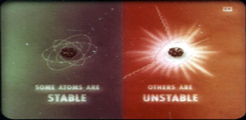
- Isotopes atoms with the same number of _____________________, but different number of ____________________.
Examples: Carbon-14 6 protons, 8 neutrons
Carbon-12 6 protons, 6 neutrons
- An atom’s ________________________ will depend on the ratio of protons to neutrons in the nucleus.
  - A nucleus with either too many or too few neutrons compared to protons is _______________________________________
- POP QUIZ: Explain why nuclear decay occurs.
_______________________________________________________________
_______________________________________________________________
_______________________________________________________________
_______________________________________________________________
- History:
  - 1896 – Henri Becquerel discovered radioactivity with __________________
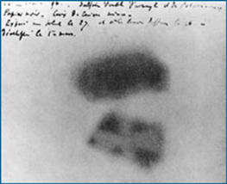
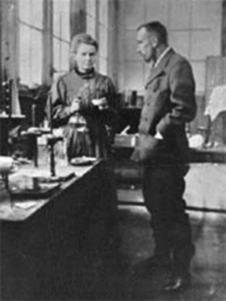
  - 1898 – Marie Curie discovered radioactivity with ___________________ and __________________

- Nuclear radiation – Particles and energy released from ____________________ nucleus. There are 3 types:
  - ______________ particles
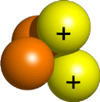
  - ______________ particles
  - ______________ rays
- Alpha particles consist of 2 _________________ and 2 _______________ with a charge of +2. They do not travel far due to _______________ and _______________. Though they are the least penetrating form of radiation, they can cause serious _____________________.

- Beta particles ________________ emitted during the decay of a neutron into a proton in an _____________________ nucleus. They can travel farther and faster than alpha particles because beta particles are so ________________.

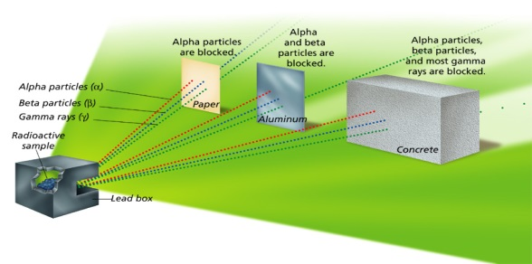
- Gamma Rays high energy electromagnetic radiation emitted by a nucleus during radioactive decay. They have no _____________ and no ______________. These rays can penetrate matter deeply, even _____________________.

