GPS – Fission and Fusion

Name____________________________ Period__________
Bellwork
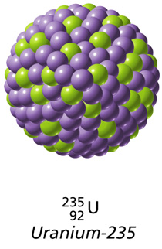 | - What are the three types of decay we talked about yesterday?
- When an atom is radioactive, it is… _____________________________________
_____________________________________________________________________
- Half-life of radioactive isotopes
a. The length of ________________ it takes _________________ of the atoms of a sample of radioactive isotopes to ___________________.
b. Varies from fractions of a __________________ to billions of ______________
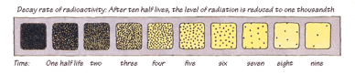
c. Do you remember plutonium’s half-life? _________________
- How can we use radioactive half-lives?
Can be used to determine the ___________ of old objects, such as
_________________________________________________________.
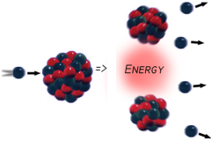
- Nuclear fission the process of ___________________________ a nucleus into two nuclei with smaller masses
- Chain reaction an ongoing series of _____________________ reactions
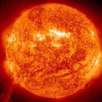
- Nuclear fusion two nuclei with low masses are _________________________ to form ONE larger _________________
a. Can only happen when nuclei are moving _______________
b. Temperature must be as high as the temperature of a ___________
Complete the review matching activity either alone or with one partner!

