General Physical Science – Naming Compounds

Name____________________________ Period__________

I can…
Construct the name of binary ionic and covalent compounds using nomenclature rules.

Bellwork
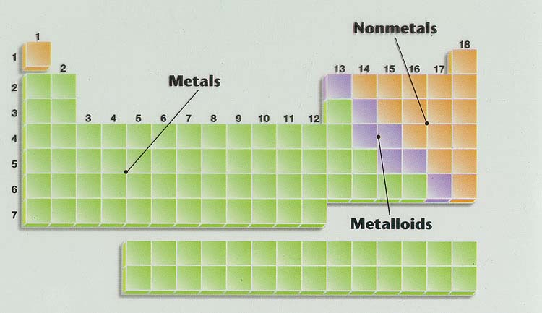 | 1. What is the difference between an ionic bond and a covalent bond?  _____________________  _____________________  2. Give an example of an ionic bond.  _____________________  _____________________  3. Give an example of a covalent bond.  _____________________  _____________________

Notes

- Chemists have a system for naming all types of compounds. Why would this be important?
_____________________________________________________________________
_____________________________________________________________________
- Some compounds have common names that are used, like H₂O is ___________.
- We will learn the steps for naming both ionic and covalent compounds. We will name only _____________________ compounds, meaning they have only two parts.

- These are the steps for naming binary ionic compounds:
    - ________________ first, then __________________
CaCl₂
A. Calcium
B. Chlorine
C. Chlor + ide
Calcium chloride
    - Write the metal name.
    - Write the root of the ________________ and add ___________ to the end.
Examples (write the names of the following):
      - NaCl _______________________________
      - CaBr₂ ______________________________
      - Na₃P ______________________________
- These are the steps naming binary covalent compounds:
  - The nonmetal farthest on the __________ of the table is written first.
  - Add ___________________ to indicate numbers of atoms.
  - Never write the prefix “mono-“ for the ___________ element.
Prefix | Number
 | 1
 | 2
 | 3
 | 4
 | 5
 | 6
 | 7
 | 8
 | 9
 | 10
  - Change the ending to ______________ for the second element.
NO₃
A. Nitrogen + oxygen
B. Mononitrogen trioxygen
C. MonoNitrogen trioxygen
D. Nitrogen trioxide
(notice for oxygen, you drop the “y” and change to “i”!)

- Try these covalent compounds on your own:
CCl₄ = ______________________________N₂O = ______________________________
SF₆ = _______________________________

