General Physical Science – Car Velocity Lab

Name____________________________ Period__________

I can…
Interpret graphs of speed and velocity.
http://shakerscience.weebly.com/general-physical-science.html
Pre-Lab Questions
- Read the intro tab. What is the difference between speed and velocity?
- Read the intro tab. What is acceleration?
- Click and read the vectors tab. What does the length of the green arrow represent?
- What does the purple arrow represent?
- Click and read the speed tab. What does the speedometer show?
- Click and read the GRAPH tab. What does a horizontal line on the graph mean?
- Click and read the GRAPH tab. What does a diagonal line on the graph that slants upward mean? What if it slants downward?

Velocity lab
- Click the “Start” button. To pause your graph and car at any time during the lab, click the “Instructions” button to the left.
- Click the “FASTER” button one time. What does the green arrow look like?
- Click the “FASTER” button two times. HOW did the green arrow change?
- Look at the graph. What are the axis labels?
- Your car should still be moving at a constant velocity. What does the graph look like? Sketch it in the space to the right. | 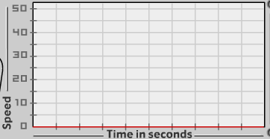
- Move your car to the left or the right. Did your graph change?
- Click the “FASTER” button a few times, then pause the graph with the “INSTRUCTIONS” button. What does the graph look like? Sketch it to the right.
- Click the “SLOWER” button several times until the car stops, then pause the graph with the “INSTRUCTIONS” button. What happened to the graph? Sketch it in the space to the right.
- 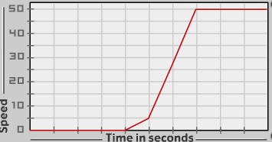Try to manipulate the car to create a graph that looks like the one shown above. Describe what the car did.
- 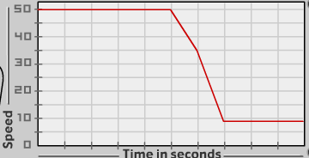
Try to manipulate the car to create a graph that looks like the one above. Describe what the car did to create this graph.
- 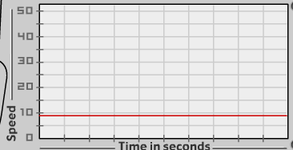
Try to manipulate the car to create a graph that looks like the one above. Describe what the car did to create this graph.

Conclusions
- The green arrows were supposed to represent vectors. Write the definition of a vector.
- Why is an arrow a good representation of a vector?
- Why were we able to change the direction of the car, and the graph did not change? (Hint—is speed the same as velocity?)
- Sketch a graph below of a car traveling at 10 m/s for 10 seconds. This is a constant velocity.
- Sketch a graph of a car traveling at 10 m/s for 5 seconds, 20 m/s for the next 3 seconds, then 30 m/s for the last 2 seconds.

