General Physical Science

Name____________________________ Period__________

I can…
define and apply concepts of motion.
apply knowledge of speed to velocity and acceleration scenarios.

Bellwork
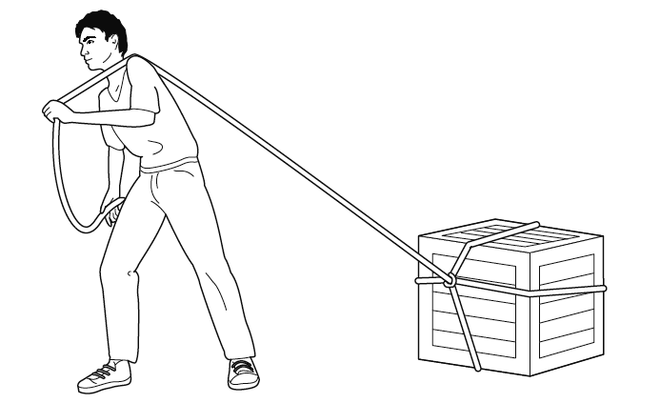 | If the box is NOT moving, and then the student pulls on it, will its velocity decrease, increase or stay the same?
Circle one
DECREASE INCREASE STAY THE SAME

Motion Notes
- _______________________ is the rate at which ___________________ changes over time.
- And object accelerates if its _________________, _______________, or both.
- Acceleration can be a change in speed.
- Acceleration can be a change in direction.
- ________________________________ is constant acceleration.

- Acceleration is the rate at which velocity changes.
- Acceleration Equation (for straight-line motion)
- $Acceleration= \frac{final velocity-initial velocity}{time}= \frac{∆v}{t}$
- In SI units, acceleration is measured in __________ per ____________ per _______________ (m/s/s or m/s²).
Math Skills
Practice some velocity problems on your own.
$Velocity= \frac{distance}{time}$ AND direction
- A plane travels 1000 miles in 5 hours in the eastward direction. What is the plane’s velocity in miles per hour?

- A kid on a bicycle rides down a hill 500 meters long in 50 seconds. What is the velocity in meters per second?

- A plan travels 500 miles south and the trip takes 5 hours. What is the velocity in miles per hour?

- A car travels north at uniform velocity a distance of 100 meters in 4 seconds. What is the velocity of the car in meters per second?

- A sailboat is traveling north 10,000 meters and it takes 16 hours to reach its destination. What is the velocity in meters per hour?

- A sprinter runs 100 m in 10 s eastward. What is his average velocity in m/s?

- It takes an olympic runner 1 second to run 5.69 meters westward. What is his velocity in m/s?

