FPS – Motion Notes

Name____________________________ Period__________

I can…
define and apply concepts of motion.
apply knowledge of distance and displacement.
Solve and interpret speed problems.

Bellwork
What is a frame of reference?

Motion Notes
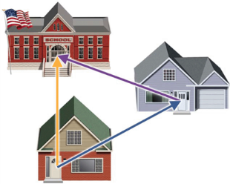
- _______________________ is an object’s change in position relative to a _______________________.
- _______________________ is the change in the position of an object.
- _______________ measures the total path taken.
- Displacement is the change of an object’s position. Displacement must always indicate _____________________.

- A quantity that has a _______________________________ (magnitude) and a ____________________________ is called a vector.
- A quantity that ONLY has a _________________________________ is called a __________________________________ quantity.
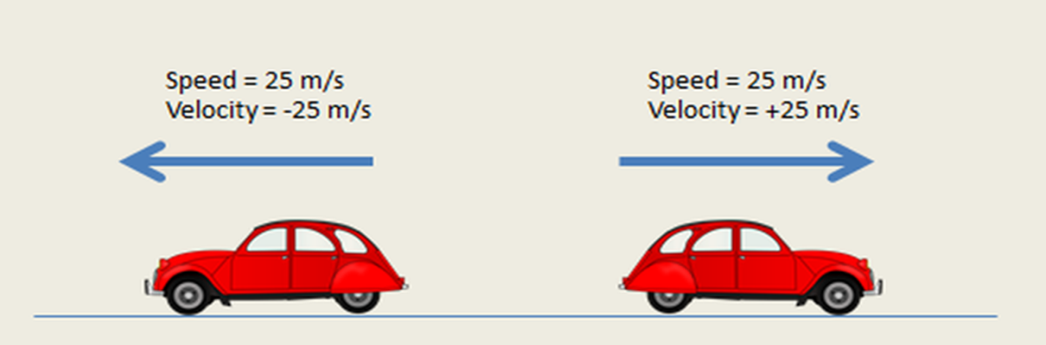

- ___________________ is the distance traveled divided by the _________________ interval during which the motion occurred. Speed describes how _________ an object moves.
- Speed measurements involve _________________ and _______________.
- The SI units for speed are _________________ per _____________ (m/s).
- When an object covers equal distances in equal amount of time, it is moving at a ______________________________.
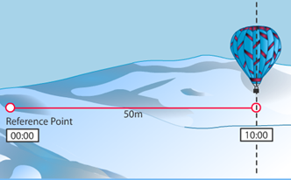 |  | $$Speed= \frac{distance}{time}= \frac{ }{ }= \frac{ }{ }$$
- Speed can be studied with graphs and equations.  Speed can be determined from a distance-time graph. When an object’s motion is graphed by plotting _______________ on the y-axis and __________ on the x-axis, the slope of the graph is speed. |  | 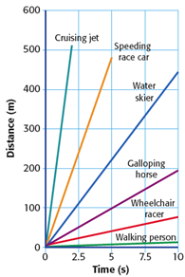
- __________________________ is the speed of an object in a particular _____________________.
- Velocity describes both __________________ and the ___________________.

Math Skills
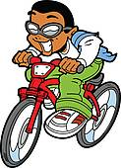 | Little Timmy rides his bicycle to school each day. He rides 1600 meters west. It takes him 3600 seconds (an hour). Find the kid’s velocity in meters per second (m/s). Remember to include direction.
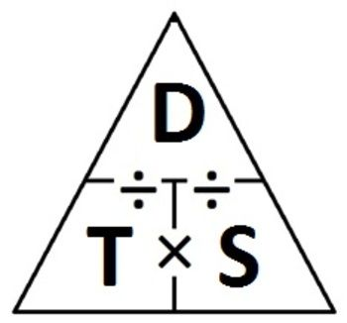
Given:
Unknown:
Perform conversions:

Use the equation for speed:
$Speed= \frac{distance}{time}= \frac{ }{ }$ =
Write the velocity by including direction:

Speed Problem Worksheet
Directions: Solve the following speed problems. Use the triangle to help solve the problems. Show all your work. Circle your answer.

- Calculate the speed for a car that went a distance of 125 meters in 2 seconds time.

- A baseball is thrown a distance of 20 meters. What is its speed if it takes 0.5 seconds to cover the distance?

- How much time does it take for a bird flying at a speed of 45 meters per second to travel a distance of 1,800 meters?

- A comet is cruising through the solar system at a speed of 50,000 meters per hour for 4 second’s time. What is the total distance traveled by the comet during this time?

- If Steve throws the football 50 meters west in 3 seconds, what is the average velocity of the football?

- If it takes Ashley 3 seconds to run east from the batter’s box to first base at an average velocity of 6.5 meters per second, what is the distance she covers in that time?

- Bart ran 5000 meters south from the cops and an average velocity of 6 meters/second before he got caught. How long did it take him to run?

- If Justin races his truck north on Highway 37 for 2560 meters in 60 seconds, what is his velocity?

- Mike rides his motorcycle at a velocity of 20 meters/second for 500 seconds, how far did he ride?

- Sarah backstrokes at an average speed of 8 meters per second, how long will it take her to complete the race of 200 meters length?

- Lauren’s SUV was detected exceeding the posted speed limit of 60,000 kilometers per hour. How many kilometers per hour would she have been traveling over the limit if she had covered a distance of 10,000 meters in 300 seconds?

- A tarantula is able to cover 0.2 meters in 5 seconds. What was the average speed of the spider?

