GPS – Measurement

Name____________________________ Period__________

Bellwork
Bellwork: What are the steps to the scientific method? Why is it important to make good observations?
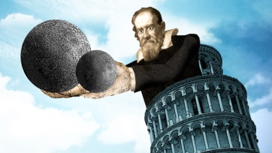
- What are some things you measure in your daily life? Why?

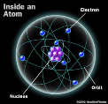
2. What are some things we measure in science?

3. Let’s hear what Bill Nye has to say about measurement.

Notes
4. Why is it important to have a standard system of measurement?

Systeme Internationale (SI Units)
Quantity | Name | Symbol
Length | Meter
Mass | Kilogram
Time | Second
Electric current | Ampere
Temperature | Kelvin
Amount of matter | Mole
Luminous intensity | Candela

Derived Units
Quantity | Name | Symbol
Area (l x w) | Square meter
Volume (l x w x h) | Cubic meter
Volume of LIQUID | Milliliter
Speed | Meter per second
Density | Kilogram per cubic meter
 | Gram per cubic centimeter
 | Gram per milliliter

5. King Henry Died by Drinking Chocolate Milk
kilo hecta deka BASE deci centi milli
meter, liter, gram
1000 100 10 1 0.1 0.01 0.001

6. Practice identifying units and type of quantity! Write the unit or quantity that matches.
- Unit to measure a cup of water __________________
- Unit to measure speed ___________________
- Unit to measure matter _____________________
- Quantity measured in kilograms _______________________
- Quantity measured in Kelvin ________________________
- Unit to measure time ________________________
- Unit to measure area _____________________
- Quantity measured in moles ________________________
- Quantity measured amperes _______________________
- Quantity measure in g/ml _________________________

Work on the next few sheets independently to prepare for our lab tomorrow!

