GPS- Graphing

Name____________________________ Period__________

I can…
construction and distinguish different types of graphs.

Introduction to Graphing – Types of graphs
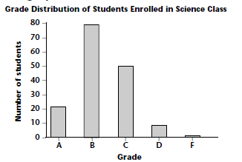 | A _________________ allows us to compare  data between ________________.
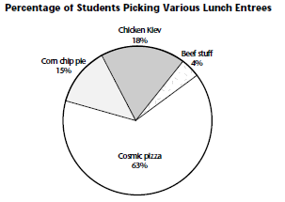 | A _____________ allows us to compare  _________ to the ___________, or percentages.
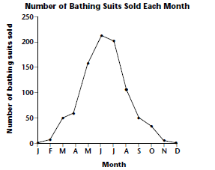 | A _____________ allows us to track  _____________, often over __________.

What should each graph have?
Let’s Practice!! Complete “Introduction to Graphing” Sheet on your own.

