GPS – Heterogeneous and Homogeneous mixtures

Name____________________________ Period__________

I can…
Distinguish between homogeneous and heterogeneous mixtures.
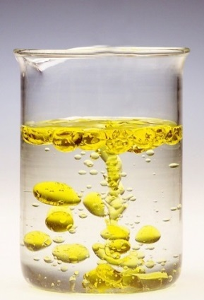
Pre-Lab Questions – Complete quietly on your own first!
- List 3 physical properties.
- What is a physical change?

Lab Demonstration
- Observe the first mixture. Describe what you see.
- The liquids are NOT chemically combined. What type of mixture is it?
- WHY do you think this is happening?
- We have observed differences in density, which is a physical property. What other physical properties can you observe?
- We will mix two substances together. Record your observations.
- This looks uniform all the way through. What type of mixture is this?

Answer the questions, and then enjoy your mixture!!
- What type of mixture is sand? Circle one. Heterogeneous / homogeneous
- Is water (H₂O) a pure substance? ____________________
- What type of mixture is vanilla ice cream? Circle one. Heterogeneous / homogeneous
- You add chocolate chips to the ice cream. What type of mixture is it now?
Circle one. Heterogeneous / homogeneous
- What is the difference between elements and compounds? Use at least one complete sentence.

