GPS – Heterogeneous and Homogeneous mixtures

Name____________________________ Period__________

I can…
Distinguish between homogeneous and heterogeneous mixtures.
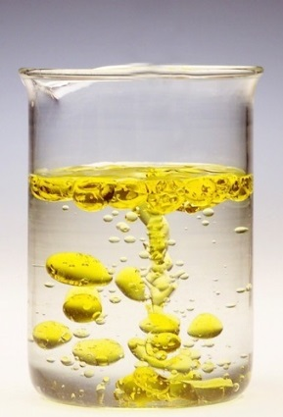
Pre-Lab Questions – Complete quietly on your own first!
- List 3 physical properties.
- What is a physical change?

Lab Demonstration
- We need one volunteer! Write the name of our volunteer. Then write the color our volunteer chose.
- PREDICT what will happen when our volunteer will put the oil and water into the bottle.

- Observe. Describe what you see.
- WHY do you think this happened?
- What is the density of water?
- What MUST the density of the mineral oil be? Estimate.
- We have observed differences in density, which is a physical property. What other physical properties can you observe?
- The liquids are NOT chemically combined. What type of mixture is this?

- We need another volunteer. Write the name of our volunteer.
- Our volunteer will mix two substances together. List the substances.
- Record your observations.
- What type of mixture is this?
- Now, see the container with just Hershey kisses. What would this represent? Each “atom” has the same properties as the rest. Is it an element, a compound, or a mixture?
- See the next container. They are chemically combined in fixed ratios. What does this represent: an element, a compound, or a mixture?
- See the next container. They are chemically combined in fixed ratios. What does this represent: an element, a compound, or a mixture?
- What type of mixture?
Answer the questions, then enjoy your mixture!!
- What type of mixture is sand? ______________________________
- What happens when a substance that has a density of 0.5 g/ml and is dropped in water?
_________________
- Is sugar a pure substance? ____________________
- What type of mixture is vanilla ice cream?____________________________
- You add chocolate chips to the ice cream. What type of mixture is it now?
____________________________________

