GPS – Gas Laws review & practice quiz

Name____________________________ Period__________

I can…
Explain Boyle’s and Charles’s Law.
Bellwork Questions – Complete quietly on your own first!
- What happens to the volume of a gas if we decrease the temperature?
- What happens to the pressure of a gas if we decrease the volume?

Notes
- Boyle’s Law
- Charles’s Law

5. Below is the practice quiz. Create an index card from your notes that you can use on the real quiz on Friday!

- What is the state of matter that has rigidly arranged molecules with very little motion?
- Which state of matter would the following image represent?
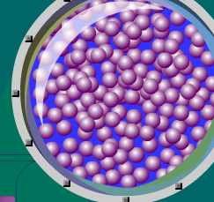
- The phase change of a liquid to a gas is called _____________________________.
- The phase change of a gas to a liquid is called _____________________________.
- The phase change of a solid to a gas is called _____________________________.
- Burning is an example of a _____________________________ change.
- Cutting a piece of paper is an example of a __________________________ change.
- On the following image, label the solid, liquid and gas.
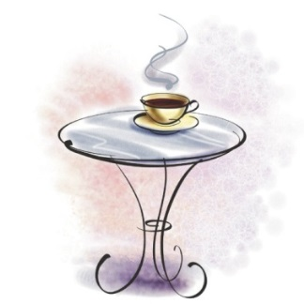
- The weather gets hotter and the temperature goes up. The volume of gas in your tires also goes up. Which law (Boyle or Charles) does this show?
- According to Boyle’s Law, what will happen to the pressure of a hot air balloon if we decrease the volume?
- According to Charles’s Law, what will happen to the volume of a balloon if we put it in the freezer?

