General Physical Science – Forces Lab

Name____________________________ Period__________

I can…
Interpret forces of motion in diagrams.

Pre-Lab Questions
- What is an unbalanced force?
Type this search into google: “Phet Forces basics”
Click the first link, then click the play button.
Forces lab
- Click the “Net Force” button. Then, check the “Sum of Forces” and “Values” check boxes. | 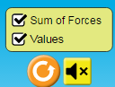
- Add a blue small person and a red small person to the rope.  Write the Sum of Forces and force values to the left. | Sum of forces =
- Click the “GO!” button.
What happens? In complete sentences, WHY?
- Add another red small person. What happens to the arrows? Sketch them and add the force values.
- Click the “GO!” button. What happens? In complete sentences, WHY??
- Add enough people to make unbalanced forces happen and sketch the arrows to the left. Include the values and units.
- Click the “Motion” page. Check the Force, Values, Masses, and Speed. 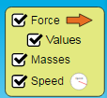
Add any combinations of objects on the cart. NOT the present. List the objects you put on the cart and their masses. Find the total mass.
- Increase the applied force to the right to 50 Newtons.
What happens to the speed? WHY?
- Click the “Friction” page. Check all the available boxes shown. Add any combinations of the objects and record the objects and their masses to the right. List the objects.
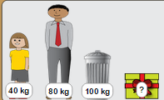
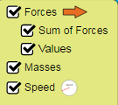
- Add applied force until the group of objects starts moving. (You may have to change objects).
Write the forces in the arrows to the right.
- Wait until the Speed maxes out. What happens immediately afterwards? Explain in complete sentences why you think this happens.
- Click the “Acceleration” page. First, check the “speed” box. And slide the “Friction” tab to none.Add 50 Newtons of Applied force.
What happens? 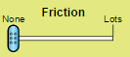
- Repeat step 13, but before the speed maxes out, change the “Friction” tab to “Lots”. What happens? WHY? 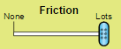
Conclusions
- In this lab, arrows are used to represent force. Using this information, do you think force is a vector? Why or why not? (Hint: vectors are measurements with direction as well.)
- Did friction add force? Which direction was the friction force added?
- What would the world be like without friction? Use complete sentences.
- What happens to the speed when you increase the force?
- What happens to the speed when you increase the mass?

BONUS: Do you think objects moving at a constant velocity have balanced or unbalanced forces? Explain your answer.

