General Physical Science

Name____________________________ Period__________

I can…
Explain the effect of gravity and air resistance.

Bellwork
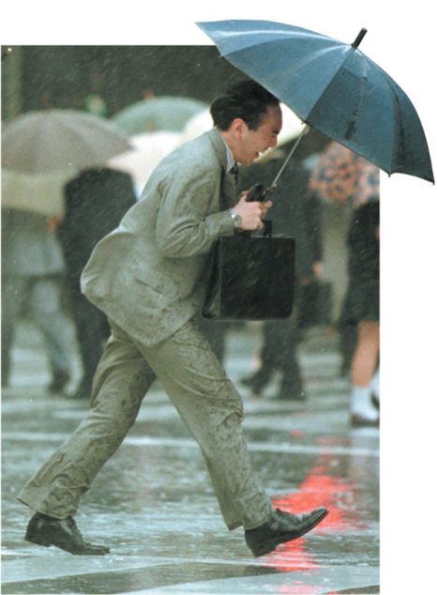 | Write which forces are acting in the photograph in the spaces below.
____________________________________________________________
____________________________________________________________
____________________________________________________________

Gravity and Falling objects
- A young Italian scientist _______________________________________________ argued that falling object fall at the same rate.
- The story goes that he dropped two _________________ from the Leaning Tower of Pisa.
- Observers were amazed that they fell at __________________________________.
- _________________________ due to gravity is _______________________.
- This is the same for all objects because it depends on ____________________ and ____________________.
To find the velocity of falling objects, use the equation:

A stone is dropped from a cliff and hits the ground after 3 sec. What is the velocity when it hits the ground?

- Air resistance is the ________________________ that opposes _________________ of objects through __________________.
Label the forces.
g=9.8 m/s²
v
t
g

- A penny at rest is dropped from the top of a tall stairwell. What is the penny’s velocity after it has fallen for 2 sec?
- The same penny hits the ground in 4.5 sec. What is the penny’s velocity as it hits the ground?
- A marble at rest is dropped from tall building. The marble hits the ground with a velocity of 98 m/s. How long was the marble falling?
- An acorn hits the ground with a velocity of 14.7 m/s. How long did it take the acorn to land?
- Complete the section summary below.

