**General Physical Science – Final Review**

Name____________________________ Period__________

Pages 44-45

|  |  |
| --- | --- |
| **Physical Property** |  |
| **Conductivity** |  |
| **Solubility** |  |
| **State** |  |
| **Malleability** |  |
| **Ductility** |  |

Pages 46-47

|  |  |
| --- | --- |
| **Density** |  |
| **The density of water is…** |  |
| **An object will sink if…** |  |
| **And object will float if…** |  |

Pages 48-49

|  |  |
| --- | --- |
| **Physical Changes** | **Examples** |

Pages 50-51

|  |  |
| --- | --- |
| **Chemical Property** |  |
| **Reactivity** |  |
| **Flammability** |  |

Pages 52-53

|  |  |
| --- | --- |
| **Chemical Change** |  |
| **Examples** |  |

Pages 66-69

|  |  |
| --- | --- |
| **3 States of Matter** | **What is matter made of?** |
| **Solid** | **_______________________Shape**  **________________________Volume** |
| **Liquid** | **_______________________Shape**  **________________________Volume** |
| **Gas** | **_______________________Shape**  **________________________Volume** |

Pages 70-72

|  |  |
| --- | --- |
| **What is temperature?** | **How does temperature affect gases?** |
| **What is volume?** | **What does the volume of a gas depend on?** |
| **What is pressure?** | **How does pressure affect gases?** |
| **Boyle’s Law** | **Charles’s Law** |

Pages 74-79

|  |  |
| --- | --- |
| **What is a change of state?** | **Melting**  **Example:** |
| **Freezing**  **Example:** | **Evaporation**  **Example:** |
| **Condensation**  **Example:** | **Sublimation**  **Example:** |
| **Label the heating curve.**  http://www.proprofs.com/quiz-school/upload/yuiupload/544116572.jpg | |

Pages 90-98

|  |  |  |
| --- | --- | --- |
| **Element** | **Pure Substance** | |
| **Categories of Elements (3) & define them** | **Compounds** | |
| **How does a property of a compound differ from its elements? (p.95)** | **How can you break down compounds?** | |
| **Mixture** | **Heterogeneous**  **Example:** | **Homogeneous**  **Example:** |

Pages 100-104

|  |  |  |  |
| --- | --- | --- | --- |
| **Solution**  **Examples:** | **Solute** | **Solvent** | |
| **Concentration** | **Solubility** | | |
| **Unsaturated (not in book)** | **Supersaturated (not in book)** | | |
| **Saturated (not in book)** | **Suspension (p.104)**  **Example:** | | **Colloid**  **Example:** |

Pages 312-317

|  |  |
| --- | --- |
| **Democritus** | **Dalton’s Atomic Theory** |
| **Atom** | **Thomson’s discovery** |
| **Electrons** | **Nucleus** |
| **Bohr’s theory** | **Electron clouds** |

Pages 318-323

|  |  |
| --- | --- |
| **Protons** | **Neutrons** |
| **Atomic number** | **Isotopes** |
| **Mass number** | **Atomic mass** |

**Mass number = neutrons + protons**

**Neutrons = mass – protons**

**The following is the periodic table square and Bohr model for Lithium. (more examples on page 365)**

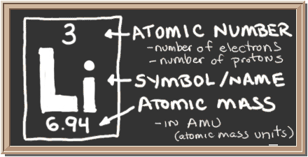 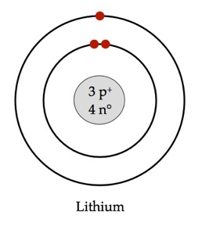

**Draw the following Bohr models.**

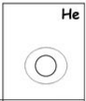 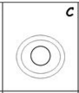 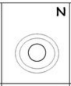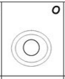 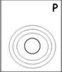

Pages 337-343

|  |  |
| --- | --- |
| **Periodic Law** | **Properties of Metals** |
| **Properties of Metalloids** | **Properties of Nonmetals** |
| **Period** | **Groups** |

Pages 364-367

|  |  |
| --- | --- |
| **Chemical bonding** | **Chemical bond** |
| **Valence electron** | **How can you find the number of valence electrons?** |
| **Filling the outermost level: what do atoms do?** | **Do all atoms need 8 valence? Why and give examples.** |

Pages 368-371

|  |  |
| --- | --- |
| **Ionic bond** | **Ions** |
| **What ions do metal atoms form?** | **What ions do nonmetal atoms form?** |
| **Crystal Lattice** |

Pages 372-376

|  |  |
| --- | --- |
| **Covalent bond** | **Molecule** |
| **What are the simplest molecules?** | **Metallic bond** |
| **How do electrons move in a metallic bond?** | **List 3 properties of metals.** |

**Lewis Dot diagrams—JUST the valence electrons**

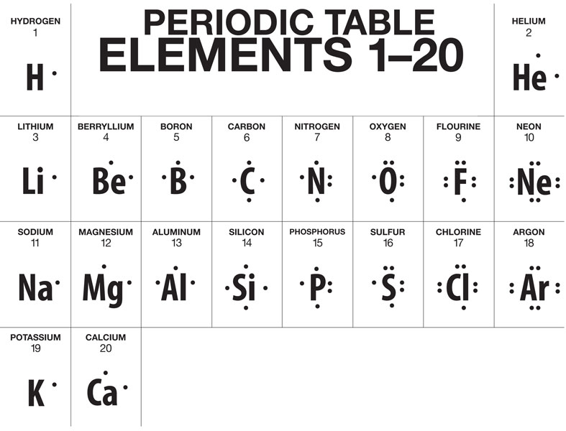

**Draw the Lewis-dot structures for:**

**Be Ne Al Cl H**

**H2O CH4 LiCl**

Pages 388-407

|  |  |
| --- | --- |
| **Chemical reaction** | **Precipitate** |
| **Give 3 ways to observe a reaction is taking place.** | **Synthesis reaction (p.398)**  **A + B 🡪 AB** |
| **Decomposition**  **AB 🡪 A + B** | **Single-displacement**  **A + BC 🡪 B + AC** |
| **Double-displacement**  **AB + CD 🡪 CB + AD** | **Exothermic reaction (p.402)** |
| **Endothermic reaction** | **Law of conservation of energy** |
| **Activation energy** | **List 5 factors affecting rate of reaction.** |

Pages 392-396

|  |  |
| --- | --- |
| **Chemical formula** | **Subscript** |
| **Writing formula for covalent compounds** | **Writing formulas for ionic compounds** |
| http://crescentok.com/staff/jaskew/isr/chemistry/prefixes.gif | |
| Name the covalent compounds below:  CO2 __________________________________  N2O__________________________________  CO__________________________________  NO3__________________________________  SO4__________________________________ | Name the covalent compounds below:  LiCl__________________________________  NaCl__________________________________  MgF__________________________________  MgO__________________________________  KBr__________________________________ |

Pages 418-421

|  |  |
| --- | --- |
| **3 properties of Ionic compounds** | **3 properties of covalent compounds** |
| **Why do ionic compounds conduct electricity?** | **Why do covalent compounds NOT conduct electricity?** |

Pages 422-424

|  |  |
| --- | --- |
| **Acid**  **What ion do they release? _____** | **List 3 properties of acids** |
| **Why do acids conduct electricity?** | **Give 3 uses of acids.** |

Pages 425-427

|  |  |
| --- | --- |
| **Base**  **What ion do they release? _____** | **List 3 properties of bases** |
| **What color does a base turn litmus paper?**  **What color does an acid turn litmus paper?** | **Give 3 uses of bases.** |

Pages 428-430

|  |  |
| --- | --- |
| **What is pH?** | **Describe the 3 main regions on the pH scale.** |
| **Is an acid with a pH of 3 strong or weaker than an acid with a pH of 5? WHY?** | **Give an example of when knowing the pH of something would be very important.** |

Pages 448-461

|  |  |
| --- | --- |
| **Radioactivity** | **Alpha particle** |
| **Beta particle** | **Gamma ray** |
| **Isotopes** | **How can radiation damage living matter?** |
| **How are alpha particles different from beta particles?** | **How are gamma rays different from particles?** |
| **Half-Life** | **Nuclear fission** |
| **Nuclear chain reaction** | **Nuclear fusion** |

Use “GPS – Stars Mini-Lesson”

|  |  |
| --- | --- |
| **What is a star?** |  |
| **How does the sun get its energy?** |  |
| **stellar equilibrium** |  |

|  |
| --- |
| **Draw the life cycle of the Sun.** |
| **Draw the life-cycle of a massive star.** |



1. Describe the size of stars in the H-R diagram (in comparison with the sun) in the upper right portion:

much larger somewhat larger the same size somewhat smaller much smaller

1. Describe the color of the stars in the upper right portion of the H-R diagram.

redder about the same color bluer

1. Describe the color of the stars in the upper left portion of the H-R diagram.

redder about the same color bluer

1. Where in the H-R diagram would you find a star with a greater temperature than the sun?

left right above below

1. Where in the H-R diagram would you find a star with a greater luminosity than the sun?

left right above below

1. What is the classification of the Sun?_____________________________
2. What is the classification of Rigel?________________________________
3. Name a star that is a Blue.___________________
4. Which star is most similar to the sun?_______________
5. What is the temperature of the sun?_______________
6. Name a star that is hotter than the sun but smaller in size __________________
7. Name a star that is cooler than the sun but larger in size___________________
8. How much dimmer than the sun is Eridani B? _________________________
9. How would you characterize the stars that are both very bright and cooler?

blue giants red giants white dwarfs red dwarfs sun-like

1. Name on star that is brighter than Aldebaran_____________________
2. What is the hottest main sequence star?___________________________