GPS – Density Group practice

Names______________________________________________________ Period__________
I can…
Calculate densities.
Predict the behavior of a material in a fluid.
In your groups, complete each section below. Each person in your group must be the recorder at least once. Write their name in the box for each section. You must all work together to complete each section. Get a teacher’s initials in the box to move on.
Section 1- Recorder Name:_________________________
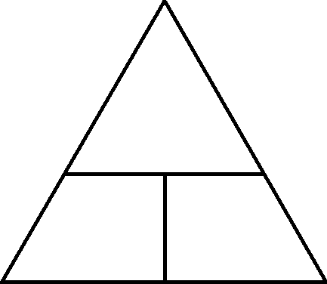
Write the formula for density and fill in the triangle.

What units do we measure density with?

What unit do we measure mass with?

What units do we measure volume with?

Section 2- Recorder Name:_________________________

What is the density (including units) of water?

What happens if something has a density more than 1 g/ml if you drop it in water?

A block has a density of 0.5 g/ml. Describe what it will do when dropped in water.

Honey has a density of 1.2 g/ml. Describe what happens when you pour honey in water. EXPLAIN WHY.

Two blocks appear to be the same size but Block A sinks and Block B floats. What about them is different?

Why is it that two objects with the same size (volume) can have really different densities?

Section 3- Recorder Name:_________________________

A metal ball has a mass of 100 g and a volume of 20 ml. What is the ball’s density? Will it sink or float in water?
A small metal cube has a mass of 20g and a volume of 5 ml. A small wood cube has a mass of 2 g and a volume of 5 ml. What are their densities?

Look at the answer to your last question. Which one will sink in water and WHY?

A very huge box has a mass of 1000g and a volume of 2000ml. What is the box’s density? What will happen if you drop the box in water?

Section 4- Recorder Name:_________________________

Refer to your triangle. What is the mass of a block that has a density of 1.3 g/ml and a volume of 200 ml?

Refer to your triangle. What is the mass of a block that has a density of 0.20 g/ml and a volume of 100 ml?

Refer to your triangle. What is the volume of a block that has a density of 3.4 g/ml and a mass of 65 g?

Refer to your triangle. What is the volume of a block that has a density of 0.96 g/ml and a mass of 3000 g?

