GPS – Chemical reactions practice quiz

Name____________________________ Period__________
Using your resources, answer the following questions.

- What is the definition of a chemical reaction?
- What is a precipitate? Be specific.
- What are two ways to determine if a chemical reaction is taking place?
- What is the word for the original substances in a chemical equation?
- What is the word for the produced substances in a chemical equation?
- What is the difference between a synthesis reaction and a decomposition reaction?
- What is the difference between a single-displacement reaction and a double-displacement reaction?
- Describe how to write the formula of a covalent compound.
- What does the Law of Conservation of Mass say?
- What is a chemical formula?
Identify the type of reactions shown in the chemical equations. Your choices are synthesis (S), decomposition (D), single-displacement (SR), double-displacement (DR), and combustion (C).
- KClO₃ → KCl + O₂ _____________________
- KBr + F₂ → KF + Br₂ _____________________
- S₈ + F₂ →   SF₆ _____________________
- Na₂SO₄ + Pb(NO₃)₂ → NaNO₃ + PbSO₄ _____________________
- C₃H₈ + O₂ → CO₂ + H₂O _____________________
- Zn + HCl → ZnCl₂ + H₂ _____________________
- FeCl₃ + Na₂CO₃ → Fe₂(CO₃)₃ + NaCl _____________________
- Na + H₂O →   NaOH + H₂ _____________________
- C₂H₆ + O₂ →   CO₂ + H₂O _____________________
- HgO → Hg + O₂ _____________________
- CaCl₂ + Na₃PO₄ → NaCl + Ca₃(PO₄)₂ _____________________
- N₂O₅ + H₂O → HNO₃ _____________________
- Mg + CuCl₂ → MgCl₂ + Cu _____________________
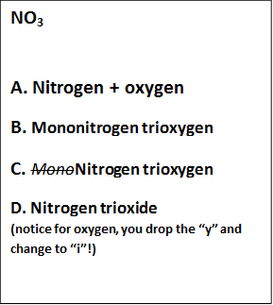
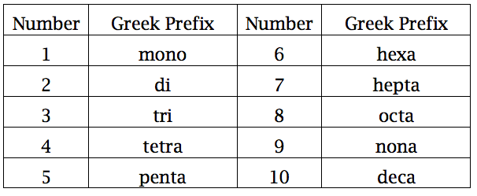
Using the prefixes and example problem below, name the following covalent compounds. For the names, give the chemical formula.
- Name SO₃ ________________________________
- Name CO ________________________________
- Name N₂O ________________________________
- Name CO₂ ________________________________
- Name N₃Cl₄ ________________________________
- Formula for sulfur hexafluoride ________________
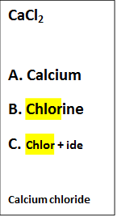
- Formula for phosphorus pentabromide ____________________
Using the example problem below, name the following ionic compounds.
- Name MgCl₂ ______________________________
- Name LiBr ______________________________
- Name K₂O ______________________________
- Name NaCl ______________________________
- Name CaF₂ ______________________________

