GPS – Types of Chemical Reactions Notes

Name____________________________ Period__________
Bellwork
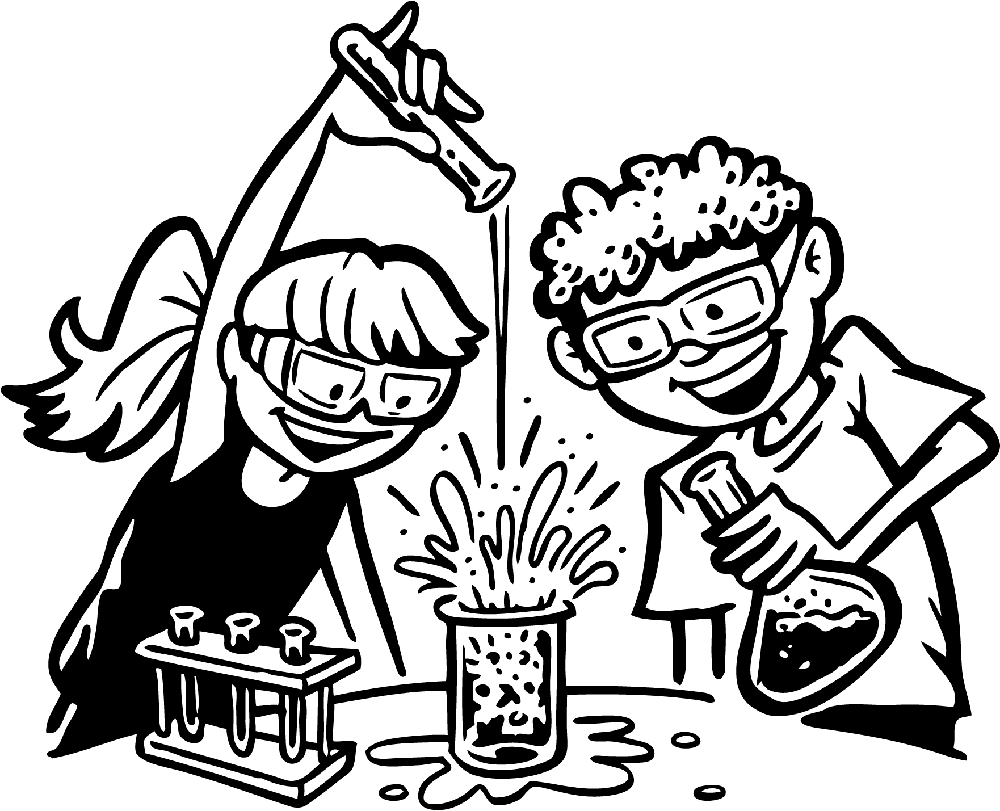 | - What is a chemical reaction? Give an example.
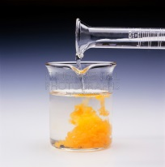
- A _________________ ____________________ is the process by which one or more substances_______________ into new substances.
- What are some things that show a chemical reaction is happening?
_______________________ _______________________
_______________________ _______________________
- What do we call a solid formation in a chemical reaction? _________________
- What are the parts in a chemical reaction?
∙ _______________________________ are the __________________ substances in the chemical reaction.
∙ _______________________________ are the substances that are _____________________ in the chemical reaction.
- Label the formula for a reaction.
2 Al + 3Br₂ 2AlBr₃
- What are the four types of reactions you read about?
_______________________ __________________________________
_______________________ __________________________________
- A _____________________________ reaction occurs when two substances, usually two _________________________ combine and form one _________________________.
A + B AB
- A ____________________________ reaction occurs when one _______________ compound is broken down into __________ __________________ substances.
AB A + B
- A ___________________________________ reaction occurs when one __________________takes the place of another in a _________________________.
A + BC B + AC
- A ________________________________ reaction occurs when ions ___________________ places in _______ _____________________.
AB + CD AD + CB
We are going to add ONE more very important reaction!
- A _______________________________ reaction is a reaction of a carbon-based compound with ____________________.
C₃H₈ + O₂ → CO₂ + H₂O

Work now on the following worksheets. You will need 4 colored pencils.

