GPS – Calculating Forces Introduction – Newton’s Second Law
Name: ___________________________________________________________

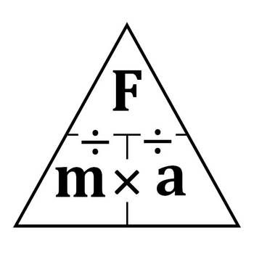
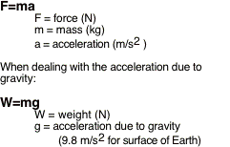

Warmup – Use the box and triangle provided.

- Force is measured in ________________ and mass is measured in _______________ and acceleration is measured in ____________________.

- If we know the force exerted on an object (in Newtons) and we know the mass of the object (in kilograms) we can easily find the acceleration the object experiences by dividing the __________ by the ______________.

- If we know the force exerted on an object (in Newtons) and we know how fast the object accelerates (in m/s²) then we can easily find the mass of the object experiences by dividing the __________ by the ______________.

- If we know the mass of an object in kilograms, and we know the acceleration that an object experiences then we can calculate the force exerted on that object by multiplying the _______________ x _____________.

Practice problems – Use the triangle and include units. SHOW ALL WORK.

1. An unbalanced force of 25 N in an Easterly direction is applied to a 12 kg mass. What will be the acceleration?

2. An unbalanced 16 N force is applied to a 2.0 kg mass. What is the acceleration?

3. A shot-putter exerts an unbalanced force of 140 N on a shot giving it an acceleration of 19 m/s2. What is the mass of the shot?

4. An object moving with a constant velocity has an unbalanced force applied to it. If the unbalanced force is -20.0 N and the mass of the object is 3.75 kg, what is the acceleration of the object while this force is acting?

5. A racing car undergoes a uniform acceleration of 8.00 m/s2. If the unbalanced force causing the acceleration is 6,000 N, what is the mass of the racing car?

6. How much force is needed to keep a 20 N stone from falling?

7. An economy car has a mass of 800 kg. What is its weight (force) if the acceleration of gravity is 9.8 m/s²?

8. A small yacht weighs (force) 14,700 N. If the acceleration of gravity is 9.8 m/s², what is its mass?

9. A 7.5 kg object is placed on a spring scale on the surface of the planet Nerdo. If the spring scale reads 78.4 N, what is the acceleration of gravity on Nerdo?

10. A car has a mass of 1200 kg. How much would the car weigh (force) on the moon where the gravitational acceleration is 1.6 m/s2?

