GPS – Quick review & Reactions intro

Name____________________________ Period__________
Bellwork
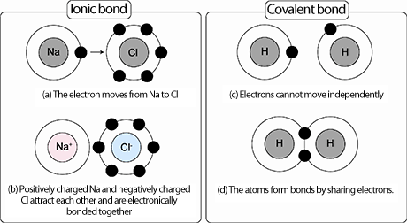 | - What do remember about ionic bonds?  - What do you remember about covalent bonds?
- Remember that atoms bond together to have a full ________________ shell, and to create _________ substances.
- This chapter, we will be looking at ________________ ______________, which is a process that one or more substances ______________ to form new substances.
- There are many different types of chemical reactions. Can you give an example of two? Write the examples below.
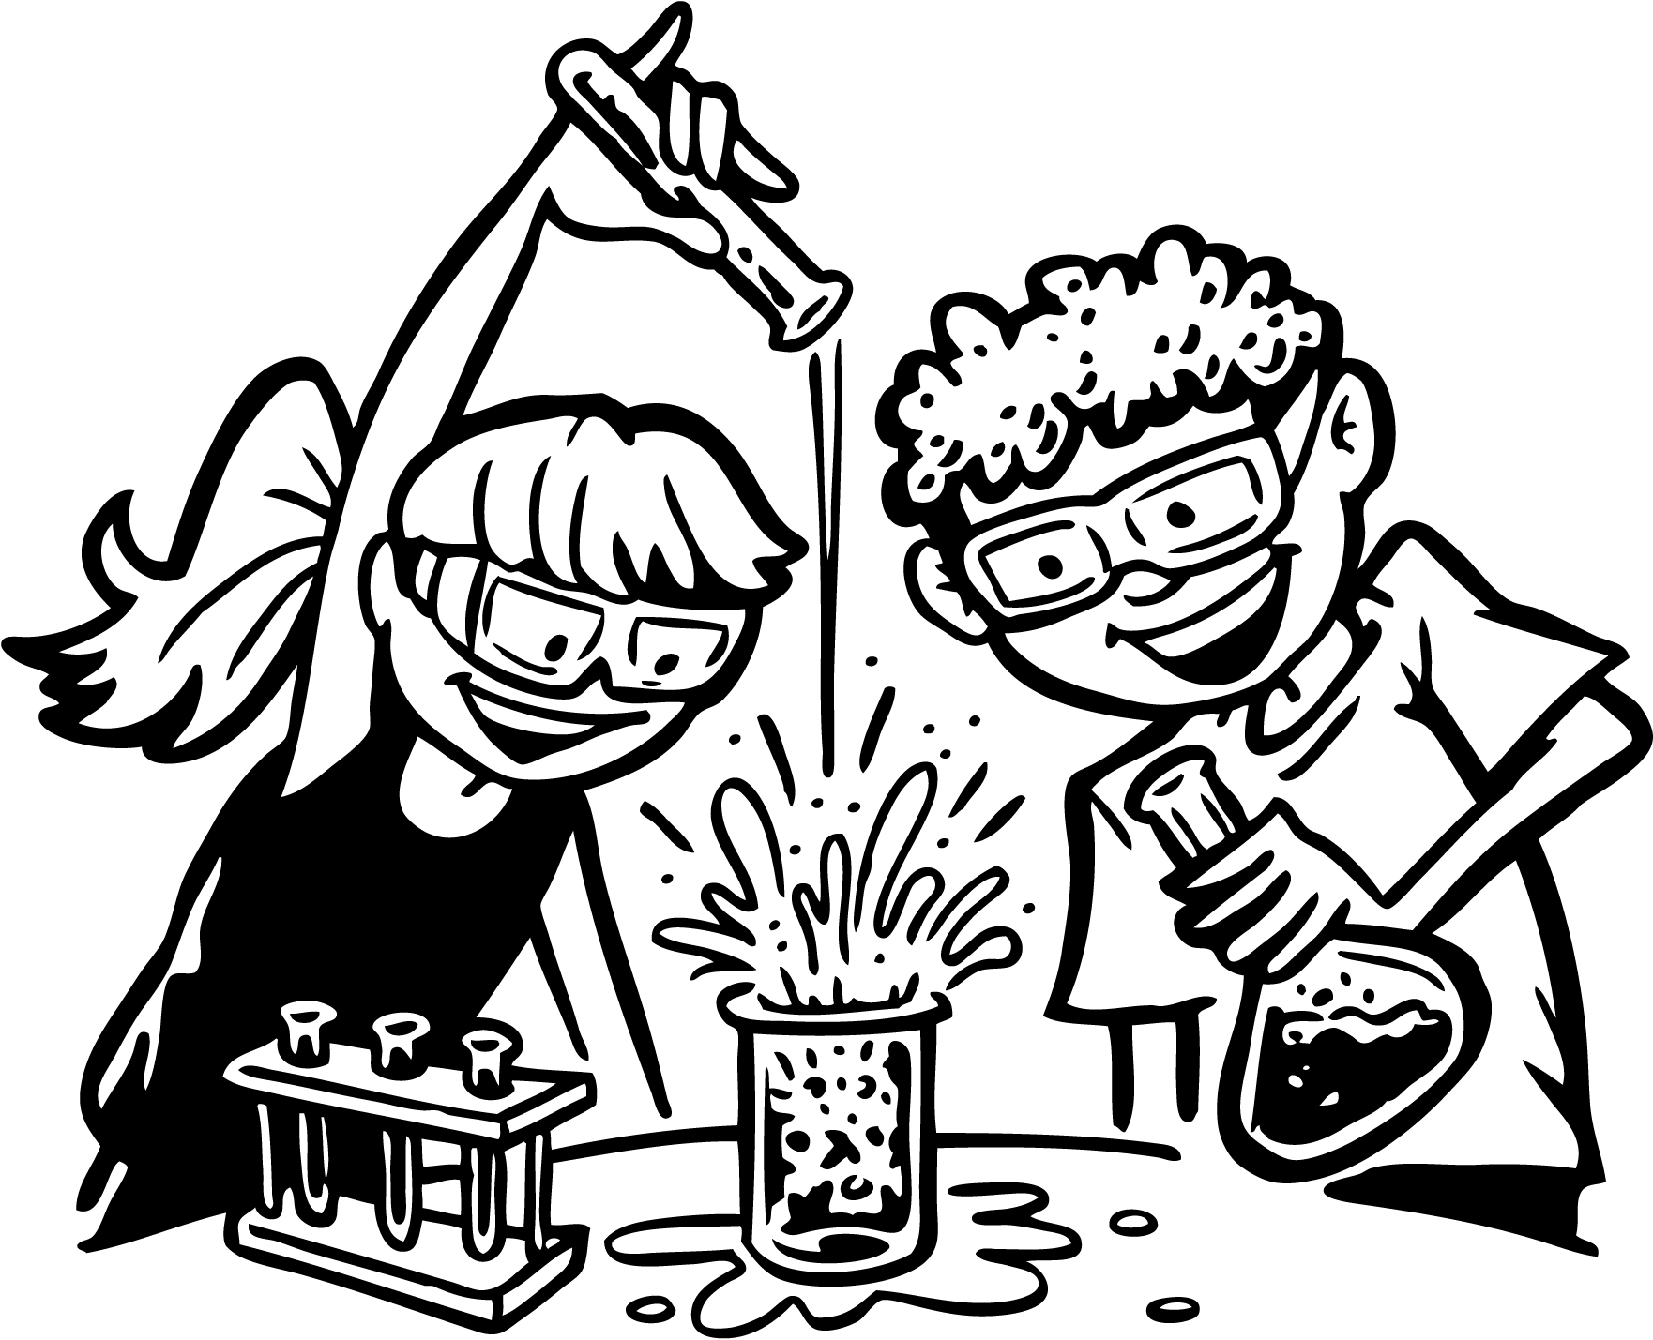 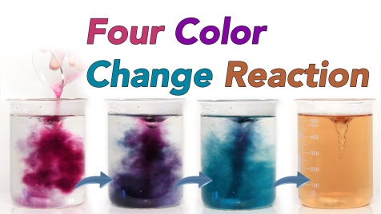

Complete the directed readings on the following pages, page numbers are provided.

Vocabulary list – Chapter 14
- Chemical reaction
- Precipitate
- Chemical formula
- Chemical equation
- Reactant
- Product
- Law of conservation of mass
- Synthesis reaction
- Decomposition reaction
- Single-displacement reaction
- Double-displacement reaction
- Exothermic reaction
- Endothermic reaction
- Law of conservation of energy
- Catalyst

