General Physical Science – Metallic Bonding Notes

Name____________________________ Period__________

I can…
Describe and represent a covalent bond.
Describe a metallic bond.

Bellwork
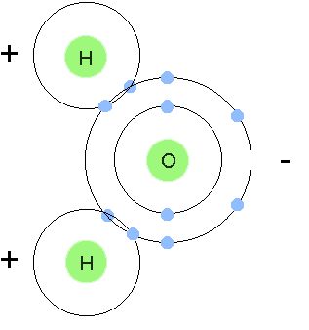 | What happens in a covalent bond?

Notes
Remind me: How do we write a Lewis dot diagram of a covalent bond? | Try H₂O.
1. We have seen _______________________________ and __________________________ of electrons. Nonmetals share with each other, and metals and nonmetal transfer.
2. What do pure metals do?
____________________________________________________________.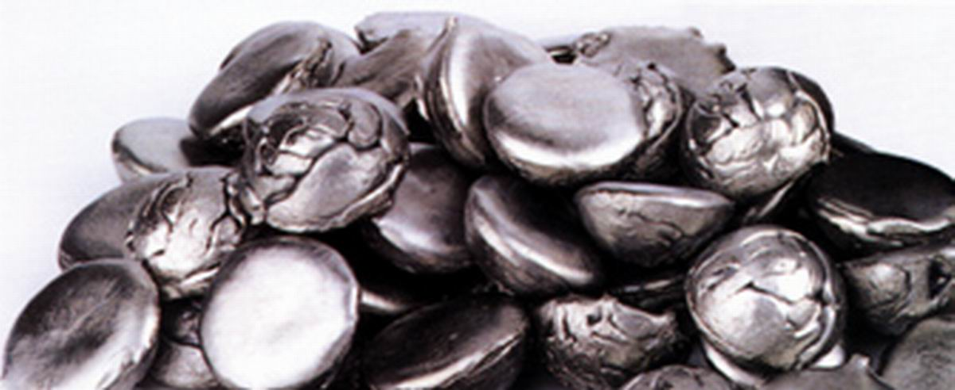
3. Metals hold onto their valence electrons very ____________________. So the electrons move around the nuclei _______________________.
4. Metals in a metallic bond are like _________________________________ existing in a ________________________________________.

5. Let’s watch a quick video to see metallic bonding in action! Follow along in your notes.
a. Metals want to ___________________ of their valence electrons.
b. Metal atoms give off their electrons no matter what because they want to become more ________________.
c. They play a _______________________ game with their electrons.
d. Since no one wants the electrons, they end up floating back and forth rapidly, which is called ________________________________________________________.
e. This flow is what gives metals their important ______________________.

6. This is why metals _____________________ electricity, are __________________, are
______________________, and ________________________.
7. Three models of chemical bonding
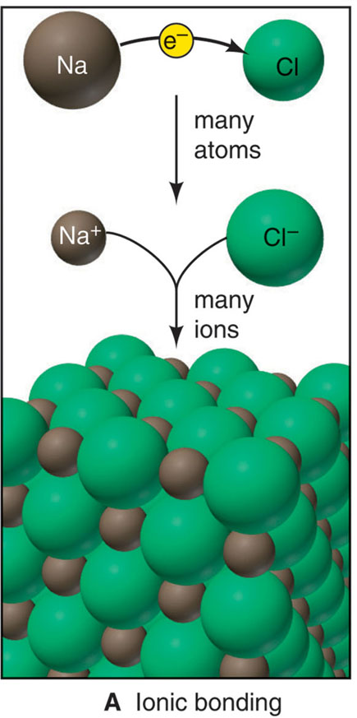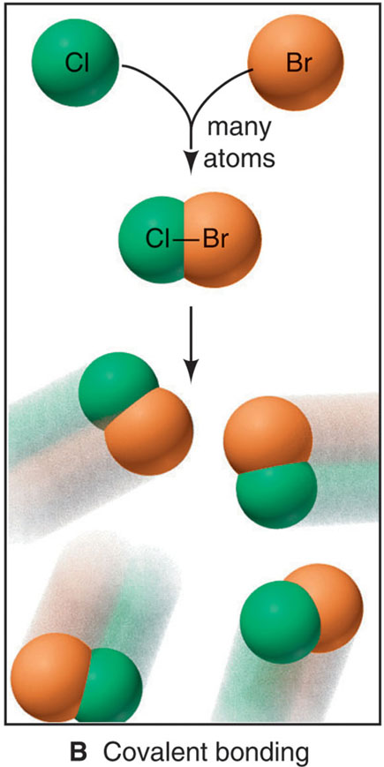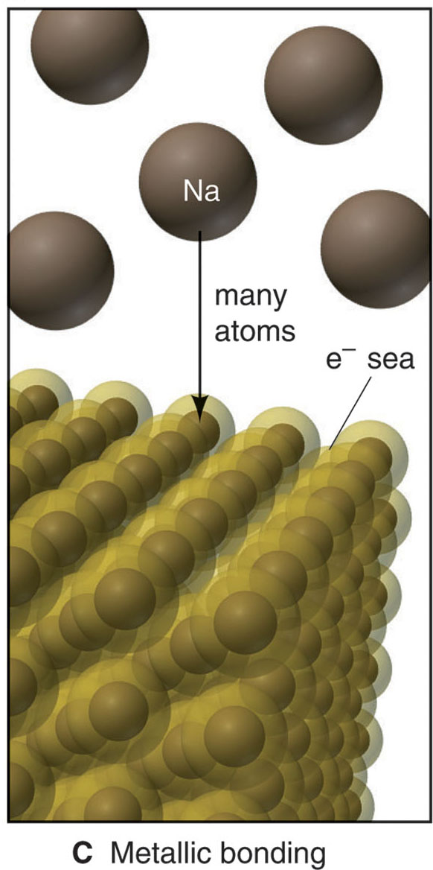
Work on the next worksheet. DUE AT THE END OF THE PERIOD.Tomorrow we will review. TEST FRIDAY.

