GPS – Bohr Models Review Worksheet

Name____________________________ Period__________
Figuring out the particles
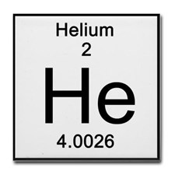

- Atomic number = number of __________________________
= number of __________________________
So for Helium: electrons ________ protons _________
- Mass = neutrons + protons
Neutrons = mass – protons
So for Helium: mass ________ -- protons _________ = neutrons _________
- Recap: Helium has _______ protons ________ neutrons ______ electrons
- In the nucleus, let’s just write the number of protons and neutrons.
- Now, add electrons to the first shell.
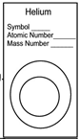
1st energy shell = ________ electrons
2nd energy shell = ________ electrons
3rd energy shell = ________ electrons

If you fill the 1st , add to the 2nd!
If you fill the 2nd, add to the 3rd!

