GPS – Solutions review

Name____________________________ Period__________
Bellwork
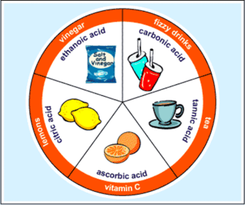 | - Last week, we learned about solutions, solubility, acids and bases. Write down 3 things you remember from last week’s lessons.
- What should we remember about mixtures and solutions?
  - Mixtures that are homogeneous are _____________________ in composition.
  - Solutions can have __________________ and __________________ bonds.
  - The solute is the part of a solution that is ___________________________.
  - The solvent is the part of a solution that is doing the __________________.
  - Solubility is the ability of the solvent to ________________________ the solute.
  - Unsaturated _______________________________________
  - Saturated _______________________________________
  - Supersaturated _______________________________________
- Acids …
a. _______________ ions
b. Tastes ________________
b. Conduct _______________________
c. ______________________________
e. Turns blue litmus paper __________________
f. Examples: __________________________________________
- Bases…
  - ______________ ions
  - Feel ________________________
  - Taste _______________________
  - __________________________
  - Conduct ____________________
  - Turn red litmus paper __________________.
- pH Scale
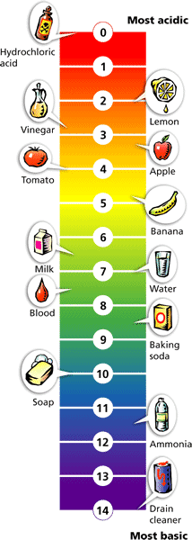
  - The pH scale ranges from _______________________.
  - Acids pH = _______________________.
  - A solution with a pH of 7 is ____________________.
  - Bases pH = ________________________.

