GPS – Acids and Bases

Name____________________________ Period__________
Bellwork
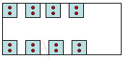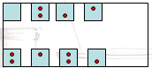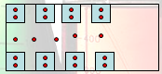 | - See the images of the seating on a bus. Using the vocabulary describing solutions, which is unsaturated, supersaturated, and which is saturated?
The Chemistry of Acids and Bases – Label the following an “acid” or a “base”
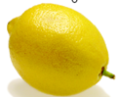 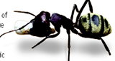
- What is an acid?
  - An _____________ is a solution that has an excess of ___________________. It comes from the Latin word acidus that means “sharp” or “sour”.
  - The more H⁺ ions, the more ____________________ the solution.
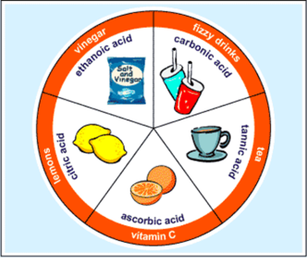
- Properties of an Acid
a. Tastes ________________
b. Conduct _______________________
c. ______________________________
d. Some acids react strongly with ______________________
e. Turns blue litmus paper __________________
- Uses of acids
  - Acetic acid = ___________________________
  - _______________ acid (lemons, limes, oranges)
  - Ascorbic Acid = _______________________ which your body needs.
  - Sulfuric acid is used in production of fertilizer, steel, paint, and plastics.
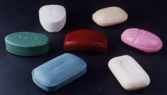
  - ____________________________
- What is a base?
  - A __________________ is a solution that has excess ___________________
  - Another word for base is ____________________.
- Properties of a base

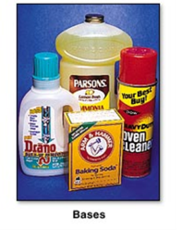
  - Feel ________________________
  - Taste _______________________
  - __________________________
  - Can conduct ____________________
  - _____ __________ ________________ with metals.
  - Turn red litmus paper __________________.
- Uses of bases
  - Bases give ______________, ammonia, and many other _____________ _____________________ some of their useful properties.
  - The OH⁻ ions interact strongly with certain substances such as dirt and grease.
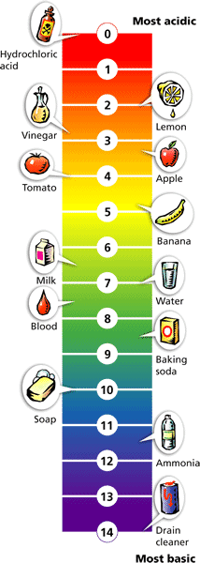
  - _________________ and over cleaner are examples of bases.
  - Your blood is a slightly _______________ solution.
- pH Scale
  - pH means “potential ______________________”
  - pH is a measure of how _____________ or basic a solution is.
  - The pH scale ranges from _______________________.
  - Acidic solutions have pH values _______________________.
  - A solution with a pH of 0 is very acidic.
  - A solution with a pH of 7 is ____________________.
  - ____________ ___________________ has a pH of 7.
  - Basic solutions have pH values of ________________________.

