GPS – Mixed Review – Velocity and Acceleration

Name____________________________ Period__________

I can…
Solve and interpret speed and acceleration problems.

Bellwork
- Acceleration in the form of a change in direction only can be shown by the example of a ________________________________.
- Acceleration in the form of a change in speed only can be shown by the example of a ________________________________.
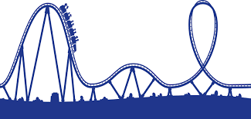
- Acceleration in the form of a change in speed and direction can be shown by the example of a ________________________________.

Acceleration
- A ______________________ acceleration means the velocity is changing positively. This usually means the object is ___________________________________.
- A ______________________ acceleration means the velocity is changing negatively. This usually means the object is ___________________________________.
- What two things in a car can change your acceleration by changing the speed?
- What can change your acceleration by changing the direction in a car?

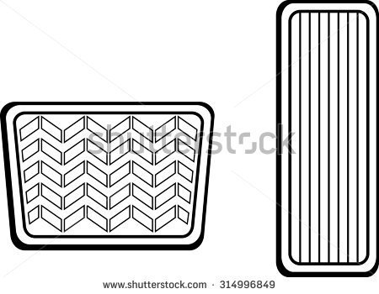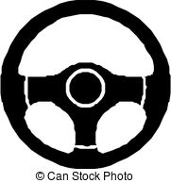

Math Skills
Let’s try a tough problem that you have to find the velocity first. You are going down a big hill on a roller coaster. At the top (your initial velocity), you are stopped for a moment. You zoom down 150 meters in 6 seconds. What is your acceleration if the whole drop takes you 3 seconds?

Given: Unknown:
Step 1: Find the speed of vf
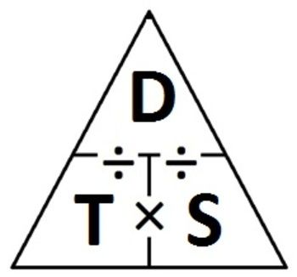
Step 2: Find a
$$a=\frac{(vf-vi)}{t}=$$
Write the acceleration by including direction:

Practice some 2 step problems with a partner! There are a few tough ones, and some easier acceleration problems for review at the end.

- A roller coaster’s initial velocity at the top of the hill is 10 m/s. It reaches the bottom of the hill, 52 meters downward, after 2 seconds. The entire change in speed takes 4 seconds. What is the acceleration of the coaster?
Given: Unknown:
Step 1: Find the speed of vf
Step 2: Find a
$a=\frac{(vf-vi)}{t}=$
Write the acceleration by including direction:
2. A roller coaster takes off westward 20 meters in 5 seconds. It begins to slow to 0.5 m/s (final velocity). The entire change in speed takes 13 seconds. What is the acceleration of the coaster?
Given: Unknown:
Step 1: Find the speed of vi
Step 2: Find a
$a=\frac{(vf-vi)}{t}=$
Write the acceleration by including direction:
3. A cat is initially running 12 meters south and it takes her 6 seconds. She speeds up to 4 m/s when she is chased by a dog. The change in speed takes a total of 10 seconds. What is her acceleration?
Given: Unknown:
Step 1: Find the speed of vi
Step 2: Find a
$a=\frac{(vf-vi)}{t}=$
Write the acceleration by including direction:

4. A flock of birds is initially flying south for the winter at 10 m/s. By the end of their journey they have slowed to only 1 meter every 1 seconds. The change in speed takes a total of 200 seconds. What is their acceleration?
Given: Unknown:
Step 1: Find the speed of vf
Step 2: Find a
$a=\frac{(vf-vi)}{t}=$
Write the acceleration by including direction:

5. If a Creature Cat’s Ferrari, with an initial speed of 10 m/sand speeds up to a final speed of 50 m/s after 3 seconds, what will its acceleration be?

6. A car advertisement states that a certain car that Emily Miller loves can accelerate from 0 to 70 m/s in 7 seconds. Find the car’s acceleration.

7. A baby lizard startles Steven Wade. The sweet little lizard accelerates from 2 m/s to 10 m/s in 4 seconds. What is the lizard’s average acceleration as he runs away from Steven?

8.Amber moves from her desk to the door in 17 seconds. Her speed changes from rest to 0.5 m/s. What is Amber’s average acceleration?

9. A cyclist named Carly Daugherty accelerates from 0 m/s to 8 m/s in 3 seconds. What is her acceleration?

10. Soul Train’s car accelerates from 0 to 30 m/s in 8 seconds. What is the acceleration?

11. Reid runs away from Joharri after an intense political debate. His initial acceleration is 0m/s and his final acceleration is 25 m/s in 10 seconds. What is Reid’s average acceleration?

12. Dominic Roth is in a roller coaster car, which rapidly picks up speed as it rolls down a slope. As it starts down the slope, its speed is 4 m/s. But 3 seconds later, at the bottom of the slope, his speed is 22 m/s. What is its average acceleration?

